INTRODUCTION
This chapter presents the study's introduction, including the background, theoretical framework, research paradigm, purpose statement, research problem, and hypothesis.
Web-based systems make providing real-time information more convenient. Online and digital dashboards can replace paper reports, which might take days to create and disseminate. Across a company, this can increase the quality and speed of decision-making. Web-based system development can result in considerable cost reductions and productivity gains for enterprises. Now that internet access is virtually universally available and internet speeds have significantly improved, applications that used to be client-based can currently be deployed on the web. Real-time data is easier to provide using web-based information systems. Paper reports, which can take days to compile and distribute, can be replaced by online reports and digital dashboards. Across an organization, this can increase the quality and speed of decision-making. (Aezion, Inc., 2022)
The main objective of this capstone project is to design a web-based system that will cover the records of all the transactions of FASA. This system will correctly handle members' information and forms of members payments. It will help the officers lessen their manual transaction process, including the payment process. For payment, the system provides an authentication password to secure the transaction. The treasurer and auditor or the admins are responsible for the said system.
BACKGROUND OF THE STUDY
Faculty Administrator and Staff Association (FASA) is an association of the teachers and staff in Bulacan Polytechnic College in which contributors deposit an amount of fifty pesos per month, and it serves as their contributions and provides funds for their projects in some facilities and development of the school. According to the treasurer of FASA, Ms. Diana Lynn Radores, the total of members is 97, including the officers. By that volume of members, records are of manual records only. The details they fill up are manual in order to increase the efficiency and effectiveness of their transaction process, the researchers recommend converting their manual transaction process into a web-based one, where the Web-based Monitoring of Contributions and Loan System for Faculty and Staff Association. A Web-based monitoring system is a system in which a contributor deposits several funds at specified intervals into their account.
A Proposed Web-based System for Faculty Administrator and Staff Association for Bulacan Polytechnic College is designed to organize the files, handle more records and avoid redundancy of the documents, secure the data of every member, for keeping monitoring up to date, and recording of payment. Recording all the transactions in FASA would not be a hassle and a waste of time. We are helping them with their daily transactions. Furthermore, this serves to awaken the industry that handles an extensive record, especially for recording the payment of all members of FASA.
Trends
Lenders and borrowers benefit from automated loan processing systems, which are necessary for various lending platforms to operate more efficiently. More technology-enabled competition and improved cloud-integrated media are transforming the lending landscape. Lenders must recognize the value of automating their processes in terms of cost savings, time savings, and efficiency, data quality, and a valuable analytical tool. While automation may create some hurdles initially, doing so in stages can help a lender's brand value lenders remain competitive and profitable in today's world. (LeadSquared,2022)
The most crucial trend in the lending industry will be more digitization. The switch will not occur immediately but rather gradually. Banks and financial institutions would be able to streamline their operations thanks to digitization. Customer information is collected, organized, and analyzed as part of these procedures. (Lead Squared, 2022)
Increased digitization will be the most crucial development in financing. The switch will not occur immediately but rather gradually. Financial institutions would be able to streamline their operations thanks to digitization. Member's information is collected, organized, and analyzed as part of these procedures. (Nidhi Agarwal, 2021)
Issues and Problems
Saving money is always difficult, especially if you live on a low income and have a lot of financial obligations. Teachers and staff in BPC have an association called Faculty and Staff Association (FASA). FASA uses a paper-based (manual) system and has some problems.
The problems include:
- FASA cannot monitor the transaction all the time.
- FASA manually computes all contributions.
- FASA cannot watch the payment of members.
- FASA members cannot pay their loans on time because of the limited face-to-face due to the pandemic.

Objectives
The goal of this research is to develop a web-based application for the Faculty, Administrator, and Staff Association (FASA). It will replace the old manual monitoring of savings and funds that is reliable, efficient, and secured to manage their account quickly. The system can monitor their contribution, know their savings and funds and pay their Contribution and Loan thru Online.
A modern automated loan processing system provides several advantages compared to traditional lending methods. It is rapidly established, flexible, offers a superior experience, enhances decision accuracy, and reduces paper documents by utilizing the newest cloud and web technologies. Automated methods speed up all steps of the loan cycle. You get hundreds to thousands of applications per week, but only a few are appropriate for your lending strategy. You can swiftly analyze and select applications that satisfy your lending criteria, underwrite confidently, notify the borrower, and fund the transaction using automated loan processing. (Defi Solutions, 2022)
General Objective
The General objective of this study is to create a Web-Based Application for Faculty, Administrator, and Staff Association (FASA) which must be acceptable to both the members and the officer-users. It will replace the old manual monitoring of savings and funds that is reliable, efficient, and secured to manage their account quickly and to know their savings and funds, and pay their Contribution and Loan Online.
Specific Objectives are: To provide a reliable web-based system where officers can easily access and monitor all the transactions of members; Provide a reliable web-based system where members of FASA can quickly pay their loan online and send their screenshot or reference number via chat to track if the admin receives their payment; To create a chat message (live chat) so that it is no longer challenging to message the officers or the treasurer; and to create a forum feature so the members can easily read the announcement and to raise their concern.

Contribution
The range of Web-based systems required to conduct vital services has long created a difficult operations management dilemma in the mainframe Computer environment. The researchers suggest a system to replace the manual operation of the Faculty, Administrator, and Staff Association (FASA) in Bulacan Polytechnic College and upgrade it to a Web-Based Application for Faculty, Administrator, and Staff Association (FASA).
Faster transactions by reducing the amount of time spent collecting, counting, and organizing currency improved hygiene by preventing the spread of bacteria through the handling of notes and coins, increased sales cash collection by shortening the time spent, collecting, counting, and organizing currency and employee entitlements management (Doug Peterson,2018)
The lack of a better monitoring system hurts their workflow. Monitoring is critical in the organization since it allows them to secure the Safety of their member's information (Paras, Dungo, and Nazal 2016)
Loan monitoring is a crucial component of good credit since it ensures that credit facilities stay within the performing loan circle, which means that past-due obligations are kept to a minimum of 90 days. It is a systemic control over the entire lending process, frequently represented in the ongoing monitoring of each loan and the overall quality of the loan portfolio. (Trade Ledger, 2021)

Statement of the Problem
The faculty Administrator and Staff Association (FASA) in Bulacan Polytechnic College have more staff. They need to have a straightforward way of recording information and status of their members' monthly contributions, loans, and expenses so that they can easily monitor and input the records of their members.
General Problem
The primary reason for this study is to develop a Web-based Application System for Faculty Administrator and Staff Association at Bulacan Polytechnic College. Researchers formulated five questions that were important in developing the system, which is:
- How could your system make the working process of the FASA faster?
- How could they make sure your system will help the FASA association?
- Who are the persons that are allowed to access the system?
- What are the basic features of the proposed plan?
- How acceptable is the Web-based Application System for Faculty Administrator and Staff Association in Bulacan Polytechnic College in terms of accuracy;
Efficiency; Reliability; Security; and User Friendliness
CONCEPTUAL FRAMEWORK
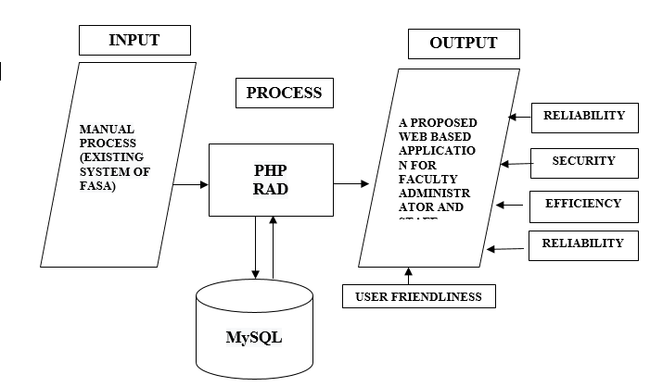
Table 1.1 Conceptual Framework of the Proposed System
The paradigm of the study, shown in figure 1.1, offers the input-process-output + Storage of the general model. It also represents the development of the existing and proposed System of Web-based Applications for the Faculty Administrator and Staff Association in BPC.
The input phase includes the Existing System used by the FASA manual System, used as one baseline data for the proposed system.
In the process phase, the study will use PHP-PHP: Hypertext Preprocessor, a server-side scripting language designed for web development and used as a general-purpose programming language. PHP originally stood for Personal Home Page, but it now stands for the recursive acronym PHP: Hypertext Preprocessor. (Upwork,2015-2022)
On the other hand, MYSQL plays the database role where the information and data needed are stored, which is the additional development phase of the proposed system. (DigitalOcean Community,2022)
In the output phase, the Proposed System has been presented, and the system will be evaluated using the following features: Reliability, Security, Efficiency, Accuracy, and User-Friendliness.

Methods and techniques
This chapter presented the methods and procedures for how the research project is to be done. It includes discussion on research methods and techniques, systems development methodology, requirements analysis, requirement documentation, software design, development, and testing, implementation plan, and implementation results.
Interview and Survey Research
Interviews are used to gather more detailed information from a small group. (Ask Talent Services,2021)
The researcher conducted a one-on-one interview with certain officers of FASA in BPC MALOLOS. After the interview, researchers surveyed related personnel on the system.

Peer to Peer Research Method.
The proponents divide the tasks to reduce workloads and increase the productivity of all team members. Dhan Ryan A. Guiñes is in charge of the system's back-end developer and head programmer. JudyAnn Palma is the head group researcher and documents, while Darcel Paytan is the system analyst and serves as the assistant group researcher. All three members serve as analysts for the system's front-end development.
Online Research Method
Online research is a research method that entails gathering information from the internet. With the advent of the internet, traditional pen-and-paper research techniques have given way to online research. (QuestionPro,2021)
The researcher used the internet to research the existing manual system regarding local studies related to the proposed system. The researchers used it as a source of reference. Also, the internet is needed in coding and programming.
TARGET CLIENTELE
The Proposed System will benefit the Faculty Administrator and Staff Association at Bulacan Polytechnic College.

DEVELOPMENT PROCESS OF THE PROPOSED SYSTEM
The Proposed system's primary purpose is to identify the common problem like a tedious recording of transactions, redundancy procedures, and time-consuming that they encounter, and the proposed system the possible solutions regarding the issues we met to the existing system they used.
Creating the Web-Based Application for Faculty, Administrator, and Staff Association (FASA) in Bulacan Polytechnic College followed the Rapid Application Development (RAD).
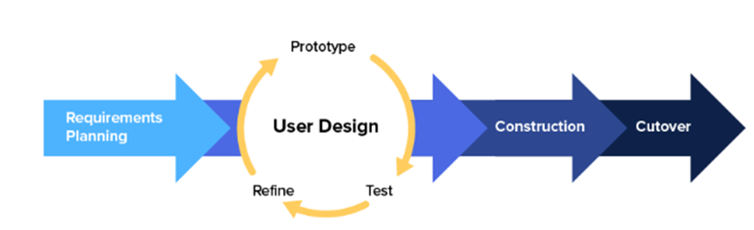
Figure 2.1 Rapid Application Development (Kissflow,2022)
Rapid Application Development (RAD) is a model that prioritizes rapid prototyping and quick feedback over long-drawn-out development and testing cycles. With rapid application development, developers can make multiple iterations and updates to software quickly without starting from scratch each time. It helps ensure that the outcome is more quality-focused and aligns with the end-users requirements. (Kissflow Inc., 2022)

REQUIREMENTS PLANNING
This stage was the initial phase in the development of the system. The proponents gather information regarding the problem identification and data collection in the form of primary data, which were directly obtained from users or final result-oriented users. It brought all user requirements related to the design of FASA. The user and the team met to identify the application's or system's goals and the information requirements arising from those objectives. The orientation in this stage involved planning to overcome existing problems.
USER DESIGN
The proponents gather information from the Officers of FASA by using interviews about their manual process. The proponents find some related studies that can be a basis for developing the proposed system.
PROTOTYPE
The proponents are shown to the clients, who choose what they like and don't like. Most of the time, these prototypes are hastily put together to highlight only the most essential elements. It is typical because the final product is only developed during the finalization step, where the system's final result is delivered to the client.
TEST
The proponents tested the system code to ensure there was no error and to detect any system malfunction before implementing the system.

REFINE
The proponents could fix the bugs and users using the system and tell the developers what worked and didn't. As a result, they reach their satisfaction.
CONSTRUCTION
They can still suggest changes or improvements as the system is being developed. Proponents asked for input from the client or the system user at every step to ensure they welcomed all changes. And it helped clear the way for the final implementation phase.
CUT OVER
The proponents plan for deployment of the proposed system, our primary goal is to replace the manual process of FASA, which is time-consuming and paper redundancy, and the change from the existing system to the new system, test the product and train the users of the system.

RESULTS AND DISCUSSION
Rating | Equivalent Range | Interpretation
5 | 4.51 - 5.00 | Highly Acceptable (HA)
4 | 3.51 - 4.50 | Acceptable(A)
3 | 2.51 - 3.50 | Moderately Acceptable (MA)
2 | 1.51 – 2.50 | Unacceptable (UA)
1 | 1.00 – 1.50 | Highly Unacceptable (HU)
Table 2.1 Likert Scale
Every data was subjected to a test to get the statistical mean of all criteria. To smooth the progress of computation and treatment of data, The Development of a Web-based Application for faculty administrator and staff association.

How good was the system?
With the help of observation, interview, and other techniques, the proposed system results from the equivalent range of 4.64 and interprets Highly Acceptable.
The system is evaluated using the following Likert Scale:A variety of methods are available to help evaluators collect data. One of these methods involves using a scale. The Likert scale is one of the most common scale types. A Likert scale is a popular tool for assessing attitudes, knowledge, perceptions, values, and behavioral changes. A Likert-type scale consists of a series of statements from which respondents can select to rate their responses to evaluative questions. (Vogt, 1999)
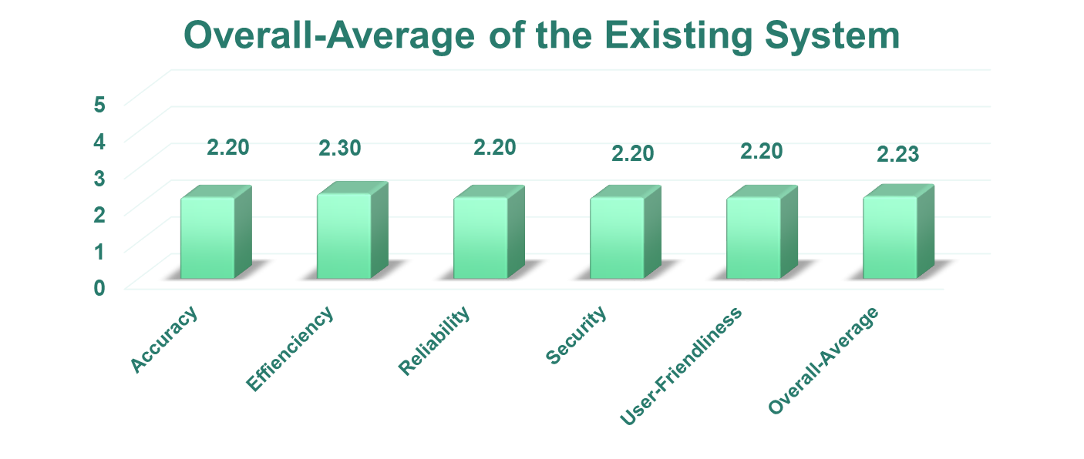
Chart 3.1: Graphical Representation of the Weighted Mean and Description of the Experts' Response to the Existing System

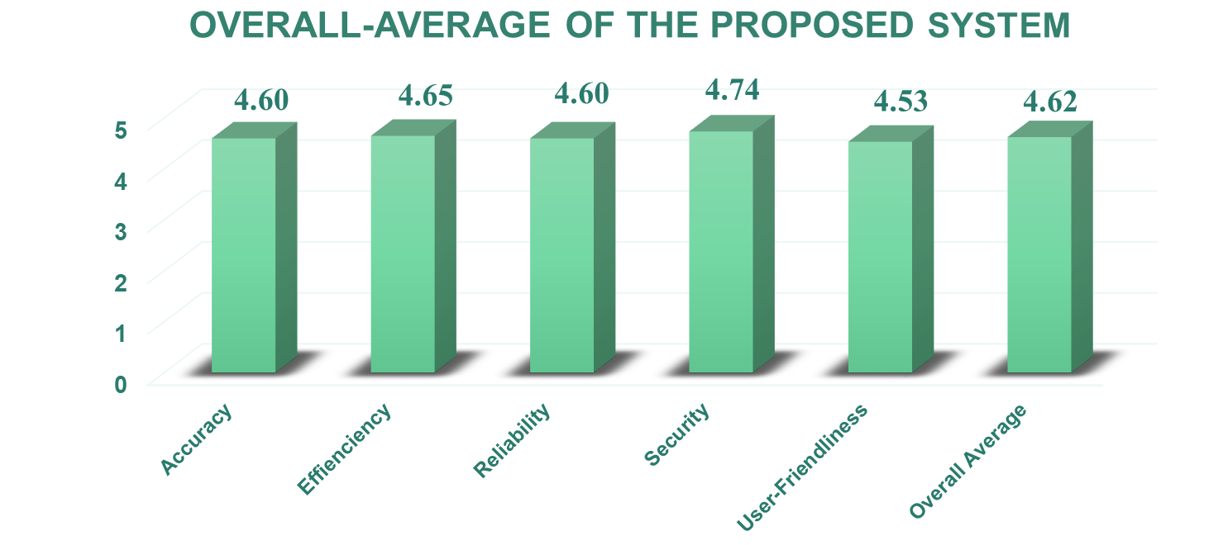
Chart 3.2 Graphical Representation of the Weighted Mean and Description of the Experts' Response to the Proposed System

COMPARISON BETWEEN EXISTING AND PROPOSED SYSTEM
According to five experts, the existing system gathered an average score of 2.23 with the verbal interpretation of Unacceptable. In contrast, the proposed system gathered an average score of 4.62, interpreted as Highly Acceptable.
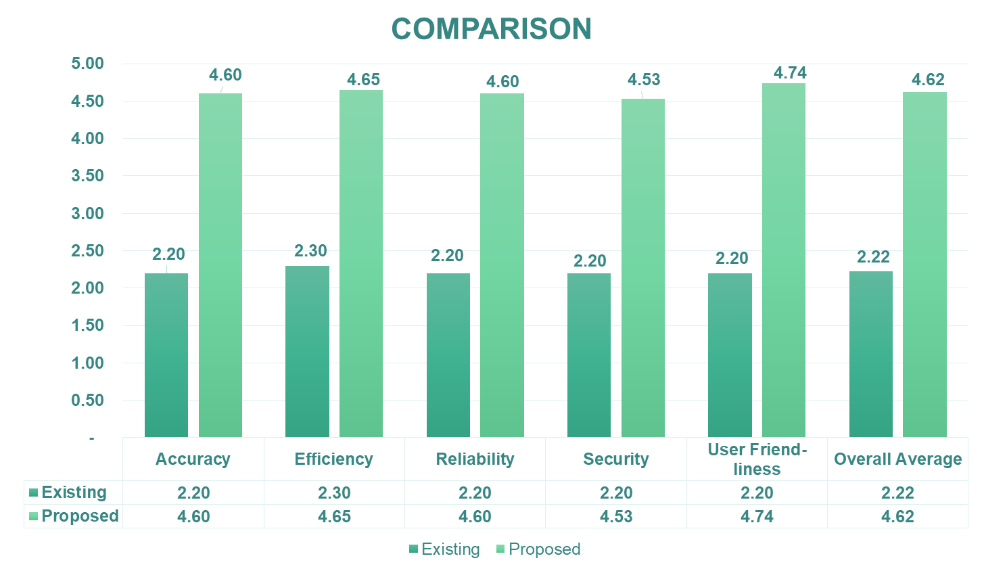
Chart 3.3 Graphical Representation of the Weighted Mean and Description of the Experts' Response to the Existing and Proposed System

SUMMARY
The Rapid Application Development (or RAD) model is based on a prototyping and iterative model with no (or less) specific planning. In disparity to the waterfall model, which emphasizes detailed specification and planning, the RAD approach means building on continuously evolving requirements, as more and more learnings are drawn as the development progresses. In general, the RAD approach to software development means focusing less on planning tasks and more on growth and developing a prototype.
Faculty Administrator and Staff Association handle the volume of data of member's monitoring of contribution, payment of members, payment of loan payment, expenses, and making reports are tedious for the officer of FASA.
The Microsoft Excel software they use requires redundancy of the member's information and all the transactions.As the number of members increases, A Proposed Web-based Application for the Faculty Administrator and Staff Association that eliminates redundancy of all transaction records.
1. Based on the experts' evaluation, the proposed system is acceptable in terms of performance criteria, has a general weighted mean of (4.62), and is interpreted as Highly Acceptable.
2. The data shown on the system validation and records inserted in the database are correct. The system can easily find specific documents. It is also easy to access and could monitor the records of all the members.
3. Regarding reliability, the admin can easily edit the information if there is an error and can easily back up. The system can also monitor every action inside the system and assure the transparency of every transaction.
4. Only authorized personnel can access the information of the system. It has security features like passwords, unique emails, and usernames. The function can be easily used and understood by the user. It is also responsive and accessible on other devices and web browsers.
5. The Proposed Web-based Application System will significantly help the Officers and Members of FASA at Bulacan Polytechnic College.
By using the RAD Development, the Web-based Application for Faculty Administrator and Staff Association passes the five criteria (accuracy, efficiency, user-friendliness, security, and reliability) and gets a score of 4.62 Highly Acceptable) the score of the Microsoft Excels (2.24 Moderately Acceptable). Thus, replacing the Microsoft Excel software with this web-based system seems reasonable.
CONCLUSION
The study shows that the Faculty Administrator and Staff Association's old System (Microsoft Excel) is not efficient and uses a Web-based System, which offers a significant improvement. Therefore, it is reasonable and necessary to implement.
- After undergoing Alpha Testing, the system has been observed to be utilized and implemented for further burn testing. The adjustment has to be done.
- The system is secured and reliable.
- The system sends emails quickly.
- The system is pleasant to the eyes.

As a result, the proponents conclude that A Proposed web-based application for faculty administrators and staff associations is highly recommended and reduces work and time for the officers and members of FASA.
The researchers came up with the following conclusions based on the study's findings.
1. Based on the experts' evaluation, the proposed system is acceptable in terms of performance criteria, had an overall general weighted mean of (4.62), and was interpreted as Highly Acceptable.
2. The Proposed Web-based Application System will significantly help the Officers and Members of FASA at Bulacan Polytechnic College.

RECOMMENDATIONS
The proponents strongly recommend the web-based application system for recording all the transactions to improve the performance and provide convenience to the members of FASA.
The study recommended that the proposed system replace the manual System of the Faculty Administrator and staff association.
- The proposed system is recommended as a replacement for the manual system.
- The proponents shall train the proposed system user for familiarity with the system's operations.
- After it has been approved, the system shall undergo Beta Testing.
- Constant feedback from the users is advised.

APPENDICES

APPENDIX A: REFERENCES

https://www.aezion.com/blogs/the-benefits-of-web-based-systems-for-business/

A. (2022, April 13). Rapid Application Development (RAD) | Definition, Steps & Full Guide. Kissflow, Inc. https://kissflow.com/low-code/rad/rapid-application-development/#:%7E:text=Rapid%20Application%20Development%20 (RAD) %20is, starting%20from%20scratch%20each%20time.
Agarwal, N. (2021, December 22). Lending Business Technology Trends 2022.Lead Squared.
https://www.leadsquared.com/lending-business-technology-trends/
Mbam, B. (2013, April 18). Enhancing Cooperative Loan Scheme through Automated Loan Management System | West African Journal of Industrial and Academic Research. Https://Www.Ajol.Info/Index.Php/Wajiar/Article/View/87445. https://www.ajol.info/index.php/wajiar/article/view/87445
Plarisan, C. (2016). Loan Management System. Prezi.Com. https://prezi.com/a2wlvwqj2_e7/loan-management-system/
https://www.leadsquared.com/lending-business-technology-trends/
A. (2022, April 13). Rapid Application Development (RAD) | Definition, Steps https://tradeledger.io/articles-insights/auditing-customers-remotely/& Full Guide. Kissflow, Inc. https://kissflow.com/low-code/rad/rapid-application-development/#:%7E:text=Rapid%20Application%20Development%20 (RAD)%20is,starting%20from%20scratch%20each%20time.
Agarwal, N. (2021a, December 22). Lending Business Technology Trends 2022. Lead Squared. https://www.leadsquared.com/lending-business-technology-trends/
Agarwal, N. (2021b, December 22). Lending Business Technology Trends 2022. Lead Squared. https://www.leadsquared.com/lending-business-technology-trends
https://www.leadsquared.com/loan-management-system-features-benefits/
Agarwal, N. (2022, April 21). Essential Features of a Loan Management System. (LeadSquared,2022).https://www.leadsquared.com/loan-management-system-features-benefits/
https://defisolutions.com/defi-insight/2018/06/21/advantages-automated-loan-processing-system/
A. (2022, April 13). Rapid Application Development (RAD) | Definition, Steps & Full Guide. Kissflow, Inc. https://kissflow.com/low-code/rad/rapid-application-development/#:%7E:text=Rapid%20Application%20Development%20 (RAD)%20is,starting%20from%20scratch%20each%20time.
Agarwal, N. (2021a, December 22). Lending Business Technology Trends 2022. Lead Squared. https://www.leadsquared.com/lending-business-technology-trends/
Agarwal, N. (2021b, December 22). Lending Business Technology Trends 2022. Lead Squared. https://www.leadsquared.com/lending-business-technology-trends
Mbam, B. (2013, April 18). Enhancing Cooperative Loan Scheme through Automated Loan Management System | West African Journal of Industrial and Academic Research. Https://Www.Ajol.Info/Index.Php/Wajiar/Article/View/87445. https://www.ajol.info/index.php/wajiar/article/view/87445
Plarisan, C. (2016). Loan Management System. Prezi.Com. https://prezi.com/a2wlvwqj2_e7/loan-management-system/
S. (2021a, August 12). The Benefits of Web-Based Systems for Business. Amazon.https://www.aezion.com/blogs/the-benefits-of-web-based-systems-for-business/
S. (2021b, August 12). The Benefits of Web-Based Systems for Business. Amazon.https://www.aezion.com/blogs/the-benefits-of-web-based-systems-for-business/?fbclid=IwAR3eINbRBktVf5sbuMCFP0tBDZPhHuXLy60ZDtO-

https://www.moodysanalytics.com/articles/2018/maximize-efficiency-how-automation-can-improve-your-loan-origination-process

How Automation Can Improve Your Loan Origination Process. (2018). Trade Ledger. Retrieved 2018, from https://www.moodysanalytics.com/articles/2018/maximize-efficiency-how-automation-can-improve-your-loan-origination-process
https://tradeledger.io/articles-insights/auditing-customers-remotely/

D. (2021, October 14). Loan monitoring is a huge overhead. Here's how to make it quicker and smarter. Trade Ledger®. https://tradeledger.io/articles-insights/auditing-customers-remotely/

https://www.simplypsychology.org/likert-scale.html

A. (2022, April 13). Rapid Application Development (RAD) | Definition, Steps & Full Guide. Kissflow, Inc. https://kissflow.com/low-code/rad/rapid-application-development/#:%7E:text=Rapid%20Application%20Development%20 (RAD)%20is,starting%20from%20scratch%20each%20time.
Agarwal, N. (2021a, December 22). Lending Business Technology Trends 2022. Lead Squared. https://www.leadsquared.com/lending-business-technology-trends/
Agarwal, N. (2021b, December 22). Lending Business Technology Trends 2022. Lead Squared. https://www.leadsquared.com/lending-business-technology-trends
Mbam, B. (2013, April 18). Enhancing Cooperative Loan Scheme through Automated Loan Management System | West African Journal of Industrial and Academic Research. Https://Www.Ajol.Info/Index.Php/Wajiar/Article/View/87445. https://www.ajol.info/index.php/wajiar/article/view/87445
Mcleod, S. (2022). Likert Scale Definition, Examples and Analysis | Simply Psychology. Dd. https://www.simplypsychology.org/likert-scale.html
Plarisan, C. (2016). Loan Management System. Prezi.Com. https://prezi.com/a2wlvwqj2_e7/loan-management-system/
S. (2021a, August 12). The Benefits of Web-Based Systems for Business. Amazon. https://www.aezion.com/blogs/the-benefits-of-web-based-systems-for-business/
S. (2021b, August 12). The Benefits of Web-Based Systems for Business. Amazon.
https://www.aezion.com/blogs/the-benefits-of-web-based-systems-for-business/?fbclid=IwAR3eINbRBktVf5sbuMCFP0tBDZPhHuXLy60ZDtO-u1SeAvHHv49gATUma58
https://prezi.com/a2wlvwqj2_e7/loan-management-system/ https://www.merriam-
webster.com/dictionary/contribution
https://www.merriam-webster.com/dictionary/contribution
https://jfin-swufe.springeropen.com/articles/10.1186/s40854-015-0010-9
What Is PHP and Why Should You Use It? | Upwork. (2015). Upwork. Retrieved 2022, from
https://www.upwork.com/resources/why-use-php
Drake, M. (2020, December 14). What is MySQL? (DigitalOcean Community,2022). https://www.digitalocean.com/community/tutorials/what-is-mysql
Bhat, A. (2021, October 25). Online research: Definition, Methods, Types, and execution.(QuestionPro,2021). https://www.questionpro.com/blog/execute-online-research/

APPENDIX B: SYSTEM MANUAL
System Review:
A Proposed Web-based Application for Faculty Administrator and Staff Association in Bulacan Polytechnic College is a web-based system that can monitor payment transactions and expenses online. You can pay your contributions, monthly dues, and damayan plan online and over-the-counter.

Registration/Sign Up - This is the signup form wherein the user can create their account.
Login - This is the login form wherein the user login their account
Forgot Password - The Admin can recover their password once the password is forgotten.

ADMIN MANUAL - This account manages the FASA funds, contributions, and expenses.
- Dashboard - The admin can view the total contribution, payments, and expenses. They can also view the full admins and members.

- Payment

- OTC Payment - The admin can add payments over the counter and view payment logs.
- Add Contribution Bill - The admin can add, edit, delete and retrieve the Monthly Dues and Damayan Plan Bill.
- Pending Payments - The admin can view, accept and reject the member’s proof of payment.
- Payment Logs - The admin can undo and view the transaction history of payments.
- Payment Method - The admin can add, edit and delete a payment method.
- Expense

- Add Expense - The admin can add and view the expense records.
- Expense Logs - The admin can undo and view the history of expenses.

4. Loan
- Member Qualified – The admin can check if the member is qualified for the application for the loan if the member contributed an amount of 1,000 pesos contribution and have one and a half years as a member.
- Draw Lots –The admin can draw the member’s name for the line-up on loan.
- Loan Line-Up – The admin can view, edit and delete the loan status of members
- Loan Payments - The admin can view, add, edit and delete payments.
- Completed Loans - The admin can view, edit and delete ended loans.

- Funds/Report - The admin can view funds and the history of payments and expenses.

- Manage Accounts

- Admins Account - The admin can view the details of all the admin and change their status as members.
- Members Account - The admin can view every member's details, change their status as admin/sub-admin, and delete their accounts.
- View Archive Account - The admin can view and retrieve archive accounts.

- Forum - The admin can view, add, edit and delete announcements. They can also accept and reject members' posts.

- Message Tab - The admin can message all the members for easy transactions

- Change Profile – The admin can view, add pictures and edit account information.

- Activity Log – The admin can view the record of the recent activity.

- User Log – The admin can view recent user logs.

SUB-ADMIN MANUAL - This account can only approve forum topics, pay the contributions and expenses, and apply for a loan.
- Dashboard – This is the Dashboard of Sub-admin. You can see the summary of total paid contribution, total paid, and total paid of Damayan Project and my loan (Active or Inactive), including the latest post or announcement.
- Payments – The sub-admin can pay their contribution or loan via Bank (Gcash, Union Bank, Pay Maya, and Land Bank) and print their receipt. Users can see all the transactions of their payments.

- My Loan– This is the Loan Requirements. You will go to the member's eligible list if you are qualified.

- My Reports – This is the overview of the IGP Report (Damayan Plan), Contribution Payment Reports, and Loan Reports. You can also print your receipt for every transaction.

- Forum – This is the Forum or the announcement post. The sub-admin can accept or decline a post before it appears on each user's timeline.

- Message Tab - The Sub Admin can read or reply to the admin's message.

- Notification Tab - The members can view their notifications.

- Change Profile – The Sub-Admin can view, add pictures, and edit account information.

- Activity Log – The Sub-admin can view the record of the recent activity.

MEMBERS MANUAL - This is the account that can Pay the contributions and expenses and apply for a loan.
  - Dashboard - This is the Dashboard of Members. You can see the total paid contribution, total paid, and unlimited paid of Damayan Project and my loan (Active or Inactive), including the latest post, the admin announcement, and the sub-admin.

  - Payments – The member can pay their contribution or loan via Bank (Gcash, Union Bank, Pay Maya, and Land Bank) and print their receipt. Users can see all the transactions of their payments.

  - My Loan– This is the Loan Requirements. You will go to the member's eligible list if you are qualified.
  - My Reports – This is the Overview of the IGP Report (Damayan Plan), Contribution Payment Reports, and Loan Reports. You can also print your receipt for every transaction.

  - Forum – This is the Forum announcement of the admin or the sub-admin. It may appear in your timeline once it is posted. You can mail or create a topic if the admin or sub-admin accepts it.

  - Message Tab - The Members can read the message or reply to the admin’s messages.

  - Notification Tab - The members can view their notifications.

  - Change Profile – The members can view, add pictures and edit account information.

  - Activity Log – The members can view the record of the recent activity.

APPENDIX C: WIREFRAME
Desktop Mode:
Mobile Mode:

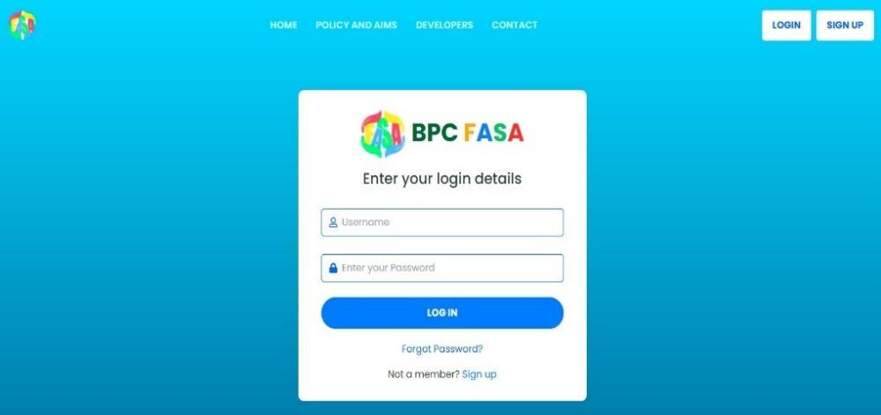

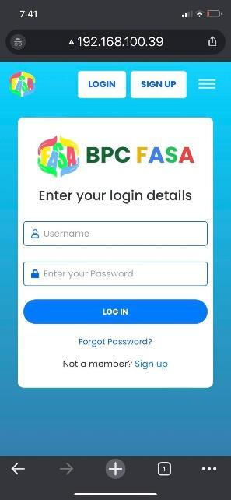

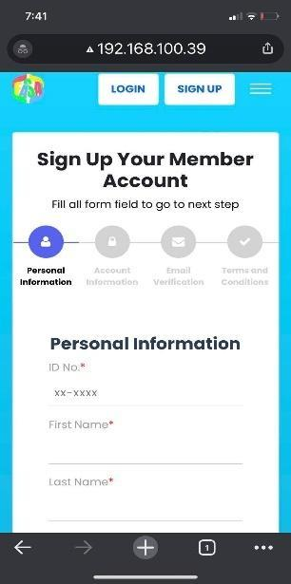
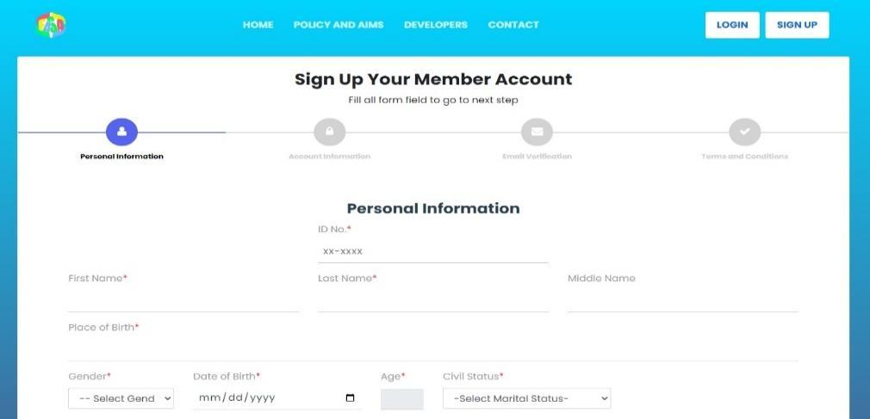

Landing, Login, Register/Sign Up Page
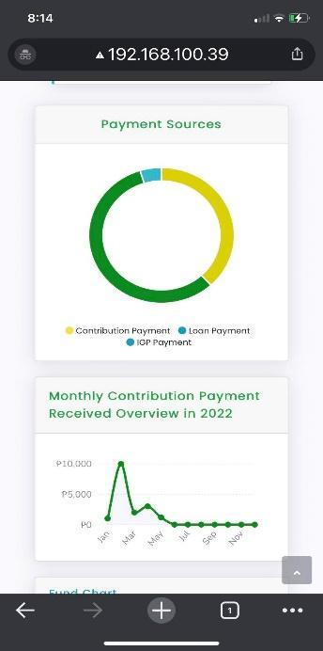
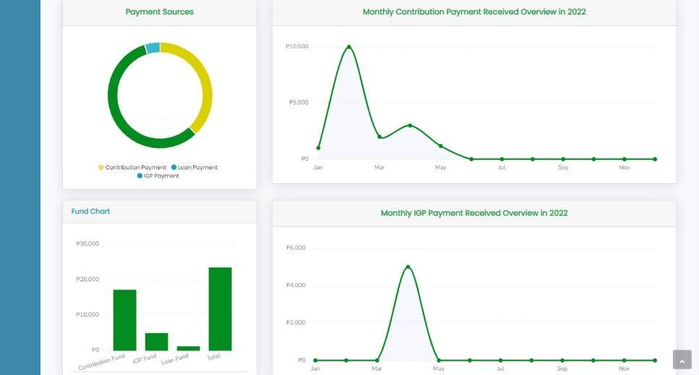
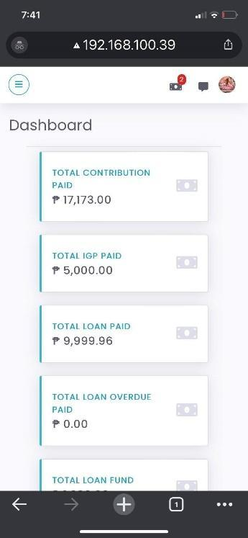
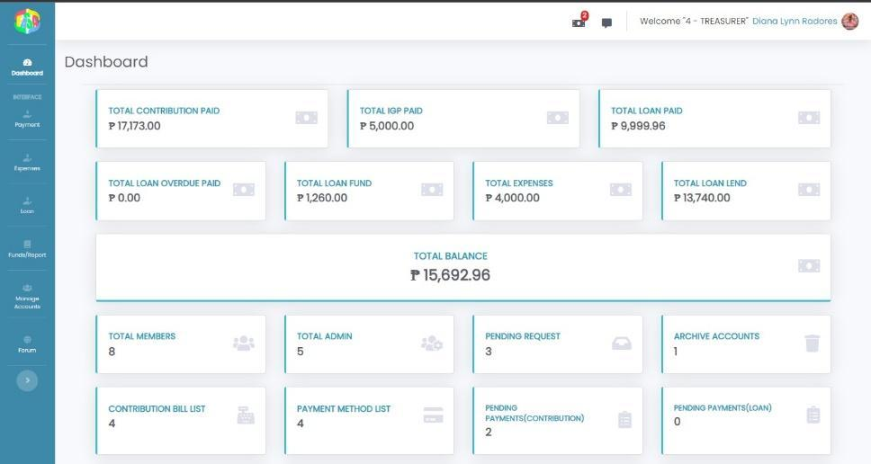

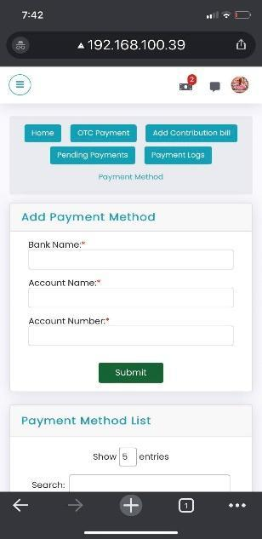
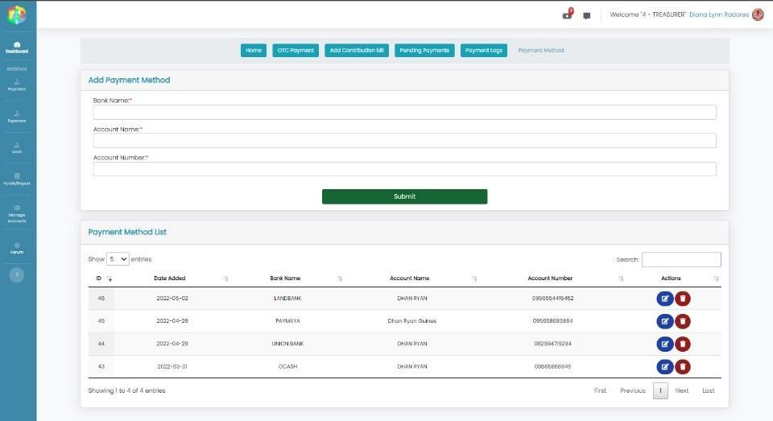
Admin Dashboard
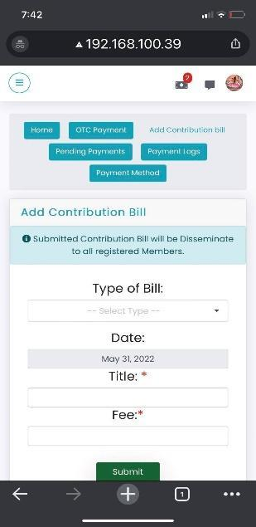
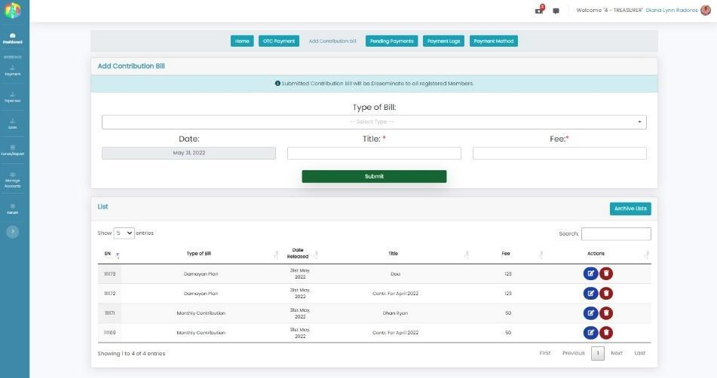

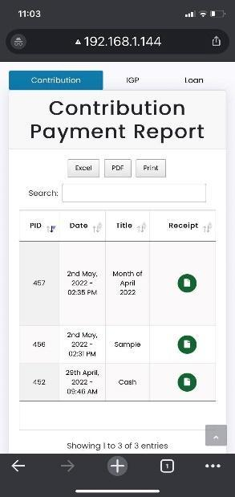
Admin: Payment Section
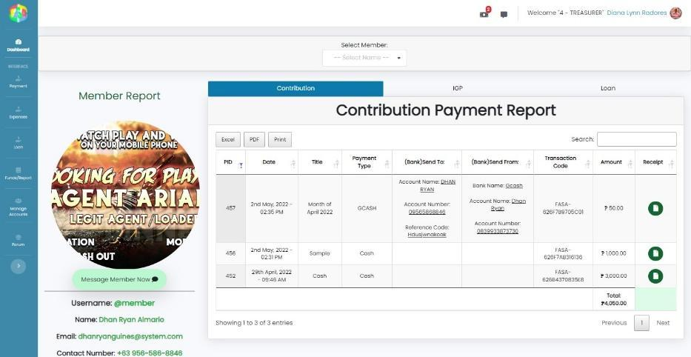

Admin: Reports Section
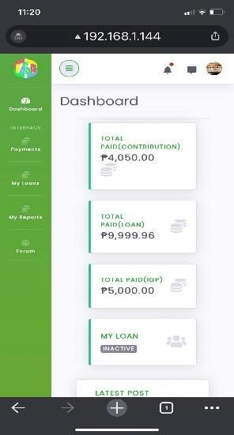
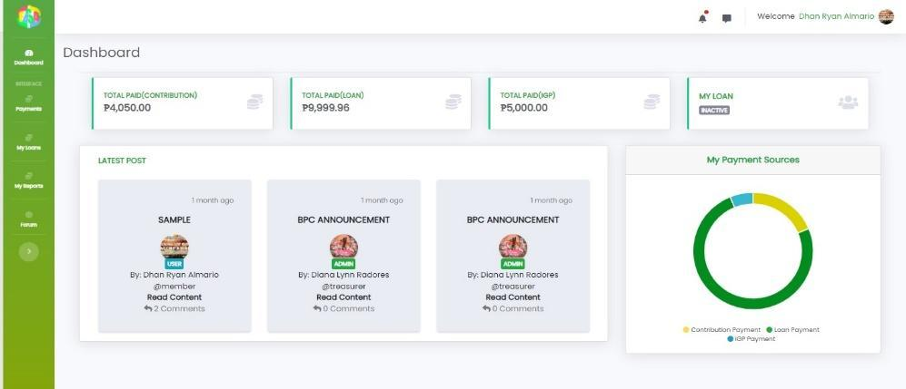

Member Dashboard

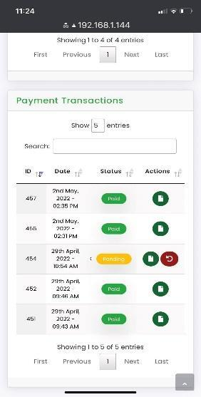
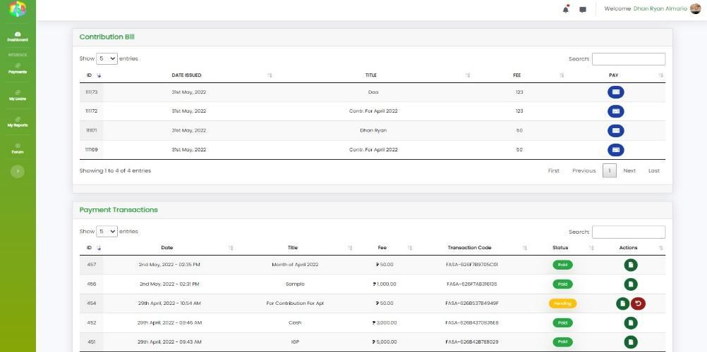

Sub-Admin & Member: Payment Tab


Sub-Admin & Member: Loan Tab
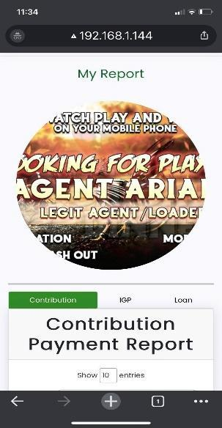
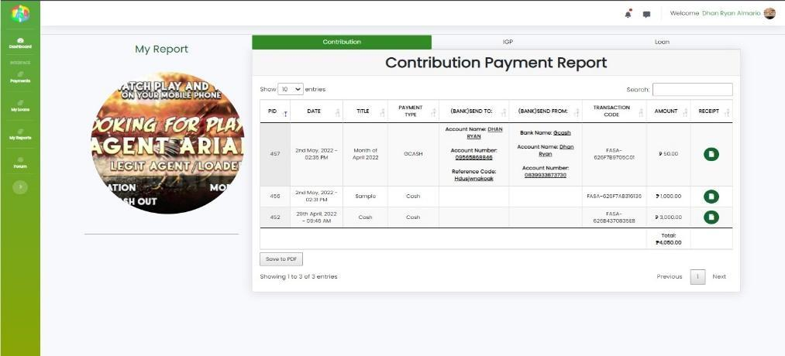
Sub-Admin & Member: Report Tab

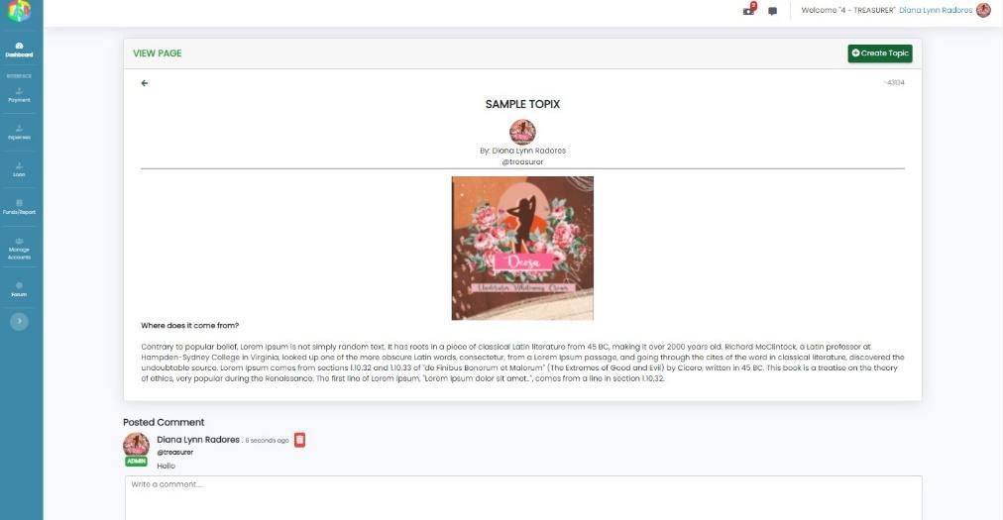

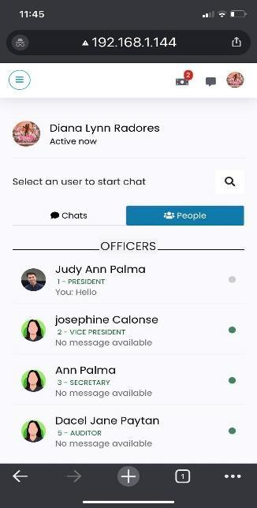
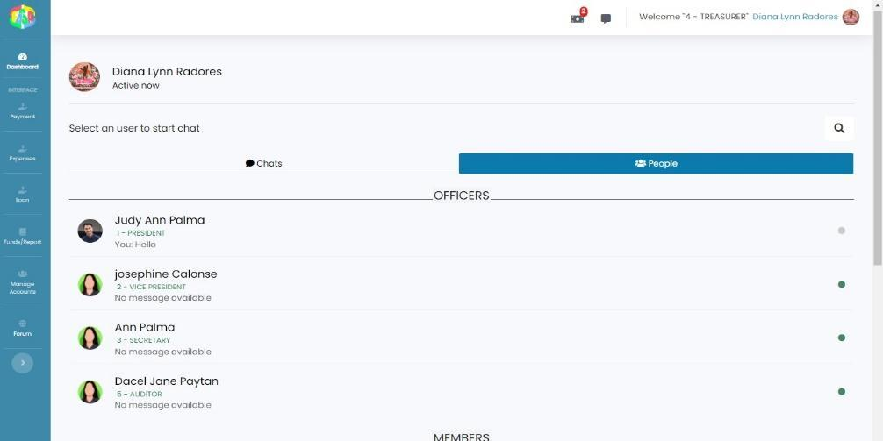
Admin, Sub-Admin, Member: Forum Page

Admin, Sub-Admin, Member: Messages Section

APPENDIX D: SOURCE CODE
Login
<?php session_start();?>
<?php
include('../includes/header.php');
include "../connection/connection.php";

?>
<style>
body{
background: rgb(62,113,160);
background: linear-gradient(0deg, rgba(62,113,160,1) 0%, rgba(0,212,255,1) 100%);
background-repeat: no-repeat;
background-attachment: fixed;
background-size: cover;
background-position: center;
}

</style>

<!-- SWEETALERT SUCCESS -->
<?php
if(isset($_SESSION['success']) && $_SESSION['success'] != ''){
?>
<script>
Swal.fire({
position: 'center',
icon: 'success',
title: 'Your password has been changed!',
showConfirmButton: false,
timer: 3000
})
</script>

<?php
// echo $_SESSION['success'];
unset($_SESSION['success']);
unset($_SESSION['email']);
}
?>
<!-- END -->

<div class="wrapper">
<div class="h1 font-weight-bolder title text-center"><img src="../assets/images/logo4-FASA.png" class="inline-block" width="80" alt=""> <span class="text-green-800">BPC</span> <span class="text-yellow-500">F</span><span class="text-blue-500">A</span><span class="text-green-500">S</span><span class="text-red-500">A</span></div>
<div class="h4 text-center pt-2 text-dark">Enter your login details</div>
<form action="login_action.php" method="post" class="pt-3">

<div class="form-group py-2">
<div class="input-field"> <span class="far fa-user p-2"></span>
<input type="text" placeholder="Username " required name="uname" id="uname"> </div>
</div>
<div class="form-group py-1 pb-2">
<div class="input-field"> <span class="fas fa-lock p-2"></span> <input type="password" placeholder="Enter your Password" required name="password" id="password"></div>

</div>

<?php if (isset($_GET['error'])) { ?>
<div class="form-group text-center text-danger" role="alert">
<?php echo $_GET['error']; ?>
</div>
<?php } ?>

<button type="submit" class="main-btn bg-primary text-white rounded-full btn-block text-center my-3">Log in</button>
<div class="text-center pt-1"> <a href="forgotpass.php" id="forgot">Forgot Password?</a> </div>
<div class="text-center pt-3 text-dark">Not a member? <a class="text-primary" href="../registration/registration.php">Sign up</a></div>

Registration/Sign Up
<?php
session_start();
include "../connection/connection.php";
date_default_timezone_set('Asia/Manila');
$time = strtotime("-18 year", time());
$date = date("Y-m-d", $time);
?>

<?php include('../includes/header.php') ?>

<style>
body{
background: rgb(62,113,160);
background: linear-gradient(0deg, rgba(62,113,160,1) 0%, rgba(0,212,255,1) 100%);
background-repeat: no-repeat;
background-attachment: fixed;
background-size: cover;
background-position: center;
}

</style>

<!-- SWEETALERT SUCCESS -->
<?php
if(isset($_SESSION['success']) && $_SESSION['success'] != ''){
?>
<script>
Swal.fire({
position: 'center',
icon: 'success',
title: 'Your account has been created successfully, please wait for admin approval',
showConfirmButton: false,
timer: 3000
})
</script>

<?php
// echo $_SESSION['success'];
unset($_SESSION['success']);
}
?>
<!-- END -->

<br><br><br>
<div class="container-fluid">
<div class="row justify-content-center mt-0">
<div class="col-11 text-center p-0 mt-3 mb-2">
<div class="card px-0 pt-4 pb-0 mt-3 mb-3">
<h2 class="h3"><strong>Sign Up Your Member Account</strong></h2>
<p>Fill all form field to go to next step</p>
<div class="row">
<div class="col-md-12 mx-0">
<form id="msform" onsubmit ="return checkval()" action="mregistration_action.php" method = "POST" >
<!-- progressbar -->
<ul id="progressbar">
<li class="active" id="personal"><strong>Personal Information</strong></li>
<li id="account"><strong>Account Information</strong></li>
<li id="payment"><strong>Email Verification</strong></li>
<li id="confirm"><strong>Terms and Conditions</strong></li>
</ul> <!-- fieldsets -->
<fieldset>
<div class="form-card">
<h2 class="fs-title text-center">Personal Information</h2>

<div class="row justify-content-center">
<div class="col-md-4">
<div class="form-group"> <label class=" mandatory required-field">ID No.</label>
<input name="idreg" id="idreg" placeholder="xx-xxxx" class="form-control"
onkeyup="idval()">
<!-- text validation -->
<p id=valId class="validation"></p>

</div>
</div>
</div>

<div class="row">
<div class="col-sm">
<div class="form-group">

<label class="mandatory required-field">First Name</label>
<input type="text" name="fname" id="fname" class="form-control" onkeypress="isInputLetter(event)" onkeyup="fnameval()">

<!-- text validation -->
<p id=valFname class="validation"></p>

</div>
</div>

<div class="col-sm">
<div class="form-group">
<label class=" mandatory required-field">Last Name</label>
<input type="text" name="lname" id="lname" class="form-control" onkeypress="isInputLetter(event)" onkeyup="lnameval()">
<!-- text validation -->
<p id=valLname class="validation"></p>
</div>
</div>

<div class="col-sm">
<div class="form-group">
<label class=" mandatory">Middle Name</label>
<input type="text" name="mname" id="mname" class="form-control" onkeypress="isInputLetter(event)">

</div>
</div>
</div>

<div class="row">
<div class="col-sm">
<div class="form-group">
<label class=" mandatory required-field">Place of Birth</label>
<input type="text" name="pbirth" id="pbirth" class="form-control" onkeypress="isInputLetter(event)" onkeyup="pbirthval()">
<!-- text validation -->
<p id=valPbirth class="validation"></p>

</div>
</div>
</div>

<div class="row">
<div class="col-sm-2">
<div class="form-group"> <label class="mandatory required-field">Gender</label>

<select id="gender" name="gender" class="form-control" onchange="genderval()"><br>
<option value="" selected="selected" disabled="disabled">-- Select Gender --</option>
<option value="man">Man</option>
<option value="woman">Woman</option>
<option value="transgender">Transgender</option>
<option value="nonbinary">Non-binary</option>
<option value="pnts">Prefer not to say</option>
</select>

<!-- text validation -->
<p id=valGender class="validation"></p>

</div>
</div>

<div class="col-sm-3">
<div class="form-group">
<label class=" mandatory required-field">Date of Birth</label>
<input type="date" id="datepicker" name="datepicker" onchange="submitBday()" class="form-control" min="1900-01-01" max="<?php echo $date;?>" onkeyup="bdayval()">
<!-- text validation -->
<p id=valBday class="validation"></p>

</div>
</div>

<div class="col-sm-1">
<div class="form-group"> <label class="mandatory required-field" >Age</label>
<input class="value form-control text-center" readonly="readonly" name="ageYear" type="text" oninput="agevalidation()" id="ageYear">
<!-- text validation -->
<p id=demo class="validation"></p>
</div>
</div>

<div class="col-sm-3">
<div class="form-group"> <label class=" mandatory required-field">Civil Status</label>
<select name="marital_status" id="marital_status" class="form-control" onchange="civilstatusval()">
<option value="" selected="selected" disabled="disabled">-Select Marital Status-</option>
<option value="Single">Single</option>
<option value="Married">Married</option>
</select>
<!-- text validation -->
<p id=valMs class="validation"></p>
</div>
</div>

<div class="col-sm-3" style ="visibility: hidden;">
<div class="form-group"> <label class="mandatory required-field">Religion</label>
<select id="religion" name="religion" class="form-control" onchange="religionval()">
<option value="" selected="selected" disabled="disabled">-- Select Religion --</option>
<option value="Roman Catholic">Roman Catholic</option>
<option value="Islam">Islam</option>
<option value="Evangelicals (PCEC)">Evangelicals(PCEC)</option>
<option value="Iglesia ni Cristo(INC)">Iglesia ni Cristo(INC)</option>
<option value="Aglipayan">Aglipayan</option>
<option value="Seventh-day Adventist">Seventh-day Adventist</option>
<option value="Bible Baptist Church">Bible Baptist Church</option>
<option value="Jehovah's Witnesses">Jehovah's Witnesses</option>
<option value="None">None</option>
<option value="Others">Others</option>
</select>
<!-- text validation -->
<p id=valReligion class="validation"></p>

</div>
</div>

</div>

<div class="row">
<div class="col-sm">
<div class="form-group">
<label class=" mandatory required-field">Address</label>
<input type="text" id="maddress" name="maddress" class="form-control" onkeyup="addressval()">

<!-- text validation -->
<p id=valAdd class="validation"></p>
</div>
</div>
</div>

<!-- divider -->
<div class="container">

<hr class="solid" style="border-top: 3px solid blue;">
</div>

<!-- Highest Educational Attainment: -->
<h2 class="fs-title text-center">Highest Education Attainment</h2>
<div class="container">

<div class="row mt-5">
<div class="col-sm-4">
<div class="form-group"> <label class=" mandatory required-field">Education</label>
<select id="education" name="education" class="form-control" onchange="educationval()"><br>
<option value="" selected="selected" disabled="disabled">-- select education --</option>
<option value="Primary education">Primary education</option>
<option value="Secondary education">Secondary education or high school</option>
<option value="Senior High education">Senior High School</option>
<option value="GED">GED</option>
<option value="Vocational qualification">Vocational qualification</option>
<option value="Bachelor's degree">Bachelor's degree</option>
<option value="Master's degree">Master's degree</option>
<option value="Doctorate or higher">Doctorate or higher</option>
</select>

<!-- text validation -->
<p id=valEduc class="validation"></p>
</div>
</div>

<div class="col-sm-5">
<div class="form-group">
<label class=" mandatory required-field">Name of School/College/University</label>
<input type="text" class="form-control" id="school" name="school" onkeyup="schoolval()" >

<!-- text validation -->
<p id=valSchool class="validation"></p>

</div>
</div>

<div class="col-sm-3">

<div class="form-group">
<label class=" mandatory required-field">Year Graduated</label>
<input type="month" min="1950-01" class="form-control" id="yrgrad" name="yrgrad" onchange="yrgradval()">

<!-- text validation -->
<p id=valYr class="validation"></p>

</div>
</div>
</div>
</div>

<!-- divider -->
<div class="container">

<hr class="solid" style="border-top: 3px solid blue;">
</div>

<!-- Employment Record: -->
<h2 class="fs-title text-center">Employment Record</h2>
<div class="container">

<div class="row justify-content-center mt-5">

<div class="col-sm-2">
<div class="form-group">
<label class=" mandatory required-field">No. in Years in BPC</label>
<input type="number" min="0" max="99"
onKeyUp="if(this.value>99){this.value='99';}else if(this.value<0){this.value='0';} yrsinbpcval()"
id="yrsinbpc" name="yrsinbpc" class="form-control" >

<!-- text validation -->
<p id=valYrsinbpc class="validation"></p>
</div>
</div>

<div class="col-sm-3">
<div class="form-group"> <label class=" mandatory required-field">Status</label>
<select id="employment" name="employment" class="form-control" onchange="statusval()">
<option value="" selected="selected" disabled="disabled">-- select status --</option>
<option value="Employed">Permanent</option>
<option value="Self-employed">Job Order</option>
<option value="Out of work">Casual</option>
<option value="Homemaker">Contract of Service</option>
</select>
<!-- text validation -->
<p id=valStatus class="validation"></p>
</div>
</div>

</div>
</div>

<div class="spousehid" id="spousehid">
<!-- divider -->
<div class="container">
<hr class="solid" style="border-top: 3px solid blue;">
</div>

<!-- Spouse Information: -->

<h2 class="fs-title text-center">Spouse Information</h2>
<div class="container">

<div class="row">
<div class="col-sm">
<div class="form-group">

<label class=" mandatory">First Name</label>
<input type="text" name="sfname" id="sfname" class="form-control" onkeypress="isInputLetter(event)">
</div>
</div>

<div class="col-sm">
<div class="form-group">

<label class=" mandatory">Last Name</label>
<input type="text" name="slname" id="slname" class="form-control" onkeypress="isInputLetter(event)">

</div>
</div>

<div class="col-sm">
<div class="form-group">

<label class=" mandatory">Middle Name</label>
<input type="text" name="smname" id="smname" class="form-control" onkeypress="isInputLetter(event)">
</div>
</div>

<div class="col-sm">
<div class="form-group">
<label class=" mandatory">Email Address</label>
<input type="text" class="form-control" id="semail" name="semail" >
</div>
</div>
</div>

<div class="row">
<div class="col-sm-3">
<div class="form-group">
<label class=" mandatory">Date of Birth</label>
<input type="date" id="datepicker1" name="datepicker1" onchange="submitsBday()" class="form-control" min="1900-01-01" max="<?php echo $date;?>">
</div>
</div>

<div class="col-sm-5">
<div class="form-group">
<label class=" mandatory">Place of Birth</label>
<input type="text" name="spbirth" id="spbirth" class="form-control" onkeypress="isInputLetter(event)">
</div>
</div>

<div class="col-sm">
<div class="form-group">
<label class=" mandatory">Occupaction</label>
<input type="text" name="socc" id="socc" class="form-control" onkeypress="isInputLetter(event)">
</div>
</div>
</div>
</div>
</div>

<!-- divider -->
<div class="container">
<hr class="solid" style="border-top: 3px solid blue;">
</div>

<h2 class="fs-title text-center">Beneficiaries</h2>
<div class="container">
<!-- Beneficiaries 1 -->
<div class="row">
<div class="col-sm-5">
<div class="form-group">
<label class="mandatory required-field">Name</label>
<input type="text" class="form-control" id="bname" name="bname" onkeyup="bnameval()">
<!-- text validation -->
<p id=valBname class="validation"></p>
</div>
</div>

<div class="col-sm-3">
<div class="form-group">
<label class=" mandatory required-field">Birthdate</label>
<input type="date" class="form-control" id="bbday" name="bbday" onkeyup="bbdayval()" onchange="bbdayval()" >
<!-- text validation -->
<p id=valBbday class="validation"></p>
</div>
</div>

<div class="col-sm-3">
<div class="form-group">
<label class=" mandatory required-field">Relationship</label>
<input type="text" class="form-control" id="brel" name="brel" onkeyup="brelval()">
<!-- text validation -->
<p id=valRel class="validation"></p>
</div>
</div>

</div>
<div class="row">
<!-- Beneficiaries 2 -->

<div class="col-sm-5">
<div class="form-group">
<label class=" mandatory">Name</label>
<input type="text" class="form-control" id="bname1" name="bname1">
<!-- text validation -->
<p id=valBname1 class="validation"></p>
</div>
</div>

<div class="col-sm-3">
<div class="form-group">
<label class=" mandatory">Birthdate</label>
<input type="date" class="form-control" id="bbday1" name="bbday1">
<!-- text validation -->
<p id=valBbday1 class="validation"></p>
</div>
</div>

<div class="col-sm-3">
<div class="form-group">
<label class=" mandatory">Relationship</label>
<input type="text" class="form-control" id="brel1" name="brel1">
<!-- text validation -->
<p id=valRel1 class="validation"></p>
</div>
</div>

</div>

</div>

</div> <input type="button" name="next" class="next action-button" value="Next Step" />
</fieldset>
<fieldset>
<div class="form-card">
<h2 class="fs-title text-center">Account Information</h2>

<div class="row">

<div class="col-sm">
<div class="form-group">
<label class=" mandatory required-field">Username</label>
<input type="text" class="form-control" id="uname" name="uname" onkeyup="unameval()">
<p id="status" class="validation"> </p>
</div>
</div>

<div class="col-sm">
<div class="form-group">
<label class=" mandatory required-field">Email Address</label>
<input type="email" class="form-control" id="email" name="email" onkeyup="emailval()">
<!-- text validation -->
<p id=valEmail class="validation"></p>
</div>
</div>

<div class="col-sm">
<div class="form-group">
<label class=" mandatory required-field">Contact Number</label>
<input class="form-control" id="cnumber" name="cnumber" placeholder="+63 xxx-xxx-xxxx" onkeyup="cnumberval()">
<!-- text validation -->
<p id=valContact class="validation"></p>
</div>
</div>

</div>

<div class="row mt-5">
<div class="col-sm">
<div class="form-group">
<label class=" mandatory required-field">Password</label>
<div class="input-group">
<input name="password" type="password" class="input form-control" id="password" onkeyup="passval()"/>
</div>
<p id=valPass class="validation"></p>
</div>

</div>
<div class="col-sm">
<div class="form-group">
<label class=" mandatory required-field">Confirm Password</label>
<div class="input-group">
<input name="cpassword" type="password" class="input form-control" id="cpassword" onkeyup="passval()"/>
</div>
<p id=valCpass class="validation"></p>
</div>
</div>
</div>

</div> <input type="button" name="previous" class="previous action-button-previous" value="Previous" />
<input type="button" name="next1" class="next1 action-button" value="Next Step" />
</fieldset>
<fieldset>
<div class="container-fluid">
<h2 class="fs-title text-center">Email Verification</h2>
<h6 class="text-center">Please enter the 6-Alphanumeric verification code we sent via Email:</h6>
<center>

<div id="codeform">
<input id="code1" name="code1" type="text" maxLength="6" class="alphanum" onkeyup="verval()"/>
<input id="btnSendCode" class="sendbtn" type="text" value="Send" onclick="sendMessage()"/>
</div>
<p id=verVal class="validation"></p>
</center>
</div> <input type="button" name="previous" class="previous action-button-previous" value="Previous" />
<input type="button" name="make_payment" class="next2 action-button" value="Confirm" />
</fieldset>

<fieldset>
<div class="form-card">
<h2 class="fs-title text-center">Terms and Conditions</h2> <br>
<div class="row justify-content-center">
<div class="col scrollable">
<h2><strong>Terms and Conditions</strong></h2>

<p>Welcome to Bpc Fasa!</p>

<p>These terms and conditions outline the rules and regulations for the use of Bpc Fasa's Website, located at bpcfasa.com.</p>

<p>By accessing this website we assume you accept these terms and conditions. Do not continue to use Bpc Fasa if you do not agree to take all of the terms and conditions stated on this page.</p>

<p>The following terminology applies to these Terms and Conditions, Privacy Statement and Disclaimer Notice and all Agreements: "Client", "You" and "Your" refers to you, the person log on this website and compliant to the Company’s terms and conditions. "The Company", "Ourselves", "We", "Our" and "Us", refers to our Company. "Party", "Parties", or "Us", refers to both the Client and ourselves. All terms refer to the offer, acceptance and consideration of payment necessary to undertake the process of our assistance to the Client in the most appropriate manner for the express purpose of meeting the Client’s needs in respect of provision of the Company’s stated services, in accordance with and subject to, prevailing law of Netherlands. Any use of the above terminology or other words in the singular, plural, capitalization and/or he/she or they, are taken as interchangeable and therefore as referring to same.</p>

<h3><strong>Cookies</strong></h3>

<p>We employ the use of cookies. By accessing Bpc Fasa, you agreed to use cookies in agreement with the Bpc Fasa's Privacy Policy. </p>

<p>Most interactive websites use cookies to let us retrieve the user’s details for each visit. Cookies are used by our website to enable the functionality of certain areas to make it easier for people visiting our website. Some of our affiliate/advertising partners may also use cookies.</p>

<h3><strong>License</strong></h3>

<p>Unless otherwise stated, Bpc Fasa and/or its licensors own the intellectual property rights for all material on Bpc Fasa. All intellectual property rights are reserved. You may access this from Bpc Fasa for your own personal use subjected to restrictions set in these terms and conditions.</p>

<p>You must not:</p>
<ul>
<li>Republish material from Bpc Fasa</li>
<li>Sell, rent or sub-license material from Bpc Fasa</li>
<li>Reproduce, duplicate or copy material from Bpc Fasa</li>
<li>Redistribute content from Bpc Fasa</li>
</ul>

<p>This Agreement shall begin on the date hereof. Our Terms and Conditions were created with the help of the <a style="color:green;" href="https://www.privacypolicies.com/blog/sample-terms-conditions-template/">Terms And Conditions Template</a>.</p>

<p>Parts of this website offer an opportunity for users to post and exchange opinions and information in certain areas of the website. Bpc Fasa does not filter, edit, publish or review Comments prior to their presence on the website. Comments do not reflect the views and opinions of Bpc Fasa,its agents and/or affiliates. Comments reflect the views and opinions of the person who post their views and opinions. To the extent permitted by applicable laws, Bpc Fasa shall not be liable for the Comments or for any liability, damages or expenses caused and/or suffered as a result of any use of and/or posting of and/or appearance of the Comments on this website.</p>

<p>Bpc Fasa reserves the right to monitor all Comments and to remove any Comments which can be considered inappropriate, offensive or causes breach of these Terms and Conditions.</p>

<p>You warrant and represent that:</p>

<ul>
<li>You are entitled to post the Comments on our website and have all necessary licenses and consents to do so;</li>
<li>The Comments do not invade any intellectual property right, including without limitation copyright, patent or trademark of any third party;</li>
<li>The Comments do not contain any defamatory, libelous, offensive, indecent or otherwise unlawful material which is an invasion of privacy</li>
<li>The Comments will not be used to solicit or promote business or custom or present commercial activities or unlawful activity.</li>
</ul>

<p>You hereby grant Bpc Fasa a non-exclusive license to use, reproduce, edit and authorize others to use, reproduce and edit any of your Comments in any and all forms, formats or media.</p>

<h3><strong>Hyperlinking to our Content</strong></h3>

<p>The following organizations may link to our Website without prior written approval:</p>

<ul>
<li>Government agencies;</li>
<li>Search engines;</li>
<li>News organizations;</li>
<li>Online directory distributors may link to our Website in the same manner as they hyperlink to the Websites of other listed businesses; and</li>
<li>System wide Accredited Businesses except soliciting non-profit organizations, charity shopping malls, and charity fundraising groups which may not hyperlink to our Web site.</li>
</ul>

<p>These organizations may link to our home page, to publications or to other Website information so long as the link: (a) is not in any way deceptive; (b) does not falsely imply sponsorship, endorsement or approval of the linking party and its products and/or services; and (c) fits within the context of the linking party’s site.</p>

<p>We may consider and approve other link requests from the following types of organizations:</p>

<ul>
<li>commonly-known consumer and/or business information sources;</li>
<li>dot.com community sites;</li>
<li>associations or other groups representing charities;</li>
<li>online directory distributors;</li>
<li>internet portals;</li>
<li>accounting, law and consulting firms; and</li>
<li>educational institutions and trade associations.</li>
</ul>

<p>We will approve link requests from these organizations if we decide that: (a) the link would not make us look unfavorably to ourselves or to our accredited businesses; (b) the organization does not have any negative records with us; (c) the benefit to us from the visibility of the hyperlink compensates the absence of Bpc Fasa; and (d) the link is in the context of general resource information.</p>

<p>These organizations may link to our home page so long as the link: (a) is not in any way deceptive; (b) does not falsely imply sponsorship, endorsement or approval of the linking party and its products or services; and (c) fits within the context of the linking party’s site.</p>

<p>If you are one of the organizations listed in paragraph 2 above and are interested in linking to our website, you must inform us by sending an e-mail to Bpc Fasa. Please include your name, your organization name, contact information as well as the URL of your site, a list of any URLs from which you intend to link to our Website, and a list of the URLs on our site to which you would like to link. Wait 2-3 weeks for a response.</p>

<p>Approved organizations may hyperlink to our Website as follows:</p>

<ul>
<li>By use of our corporate name; or</li>
<li>By use of the uniform resource locator being linked to; or</li>
<li>By use of any other description of our Website being linked to that makes sense within the context and format of content on the linking party’s site.</li>
</ul>

<p>No use of Bpc Fasa's logo or other artwork will be allowed for linking absent a trademark license agreement.</p>

<h3><strong>iFrames</strong></h3>

<p>Without prior approval and written permission, you may not create frames around our Webpages that alter in any way the visual presentation or appearance of our Website.</p>

<h3><strong>Content Liability</strong></h3>

<p>We shall not be hold responsible for any content that appears on your Website. You agree to protect and defend us against all claims that is rising on your Website. No link(s) should appear on any Website that may be interpreted as libelous, obscene or criminal, or which infringes, otherwise violates, or advocates the infringement or other violation of, any third party rights.</p>

<h3><strong>Your Privacy</strong></h3>

<p>Please read Privacy Policy</p>

<h3><strong>Reservation of Rights</strong></h3>

<p>We reserve the right to request that you remove all links or any particular link to our Website. You approve to immediately remove all links to our Website upon request. We also reserve the right to amen these terms and conditions and it’s linking policy at any time. By continuously linking to our Website, you agree to be bound to and follow these linking terms and conditions.</p>

<h3><strong>Removal of links from our website</strong></h3>

<p>If you find any link on our Website that is offensive for any reason, you are free to contact and inform us any moment. We will consider requests to remove links but we are not obligated to or so or to respond to you directly.</p>

<p>We do not ensure that the information on this website is correct, we do not warrant its completeness or accuracy; nor do we promise to ensure that the website remains available or that the material on the website is kept up to date.</p>

<h3><strong>Disclaimer</strong></h3>

<p>To the maximum extent permitted by applicable law, we exclude all representations, warranties and conditions relating to our website and the use of this website. Nothing in this disclaimer will:</p>

<ul>
<li>limit or exclude our or your liability for death or personal injury;</li>
<li>limit or exclude our or your liability for fraud or fraudulent misrepresentation;</li>
<li>limit any of our or your liabilities in any way that is not permitted under applicable law; or</li>
<li>exclude any of our or your liabilities that may not be excluded under applicable law.</li>
</ul>

<p>The limitations and prohibitions of liability set in this Section and elsewhere in this disclaimer: (a) are subject to the preceding paragraph; and (b) govern all liabilities arising under the disclaimer, including liabilities arising in contract, in tort and for breach of statutory duty.</p>

<p>As long as the website and the information and services on the website are provided free of charge, we will not be liable for any loss or damage of any nature.</p>

<article>
<center>
<input type="checkbox" id="agreecheck"/>
<div>
<span class="p-2">
Agree to Terms and Condtions
</span>
</div>
</center>
</article>

</div>
</div>

</div>

<p id=valCheck class="text-center validation"></p>
<input type="button" name="previous" class="previous action-button-previous" value="Previous" />
<input type="submit" name="submitreg" class="submitreg action-button" value="Submit" />
</fieldset>
</form>
</div>
</div>
</div>
</div>
</div>
</div>

Admin
<?php
include('includes/header.php');
include('includes/navbar.php');
date_default_timezone_set('Asia/Manila');

$sql = "SELECT * FROM members WHERE user_type = 'USER' AND account_status = 'APPROVED'";
$result = mysqli_query($conn, $sql);
$totalMembers = mysqli_num_rows($result);

$sql1 = "SELECT * FROM members WHERE user_type = 'ADMIN' AND account_status = 'APPROVED'";
$result1 = mysqli_query($conn, $sql1);
$totalAdmin = mysqli_num_rows($result1);

$sql2 = "SELECT SUM(fee) as value_sum from payee WHERE type= 'CP' AND status= 'Paid'";
$result2 = mysqli_query($conn, $sql2);
$row = mysqli_fetch_assoc($result2);
$sum = $row['value_sum'];

$total = number_format($sum, 2);

$sql21 = "SELECT SUM(fee) as value_sum from loan_payee WHERE status= 'Paid'";
$result21 = mysqli_query($conn, $sql21);
$rowip = mysqli_fetch_assoc($result21);
$sum1 = $rowip['value_sum'];

$total21 = number_format($sum1, 2);

$sql22 = "SELECT SUM(fee) as value_sum from payee WHERE type= 'IP' AND status= 'Paid'";
$result22 = mysqli_query($conn, $sql22);
$rowip1 = mysqli_fetch_assoc($result22);
$sum2 = $rowip1['value_sum'];

$total22 = number_format($sum2, 2);

$sql23 = "SELECT SUM(overdue) as value_sum from loan_payee WHERE status= 'Paid'";
$result23 = mysqli_query($conn, $sql23);
$rowip2 = mysqli_fetch_assoc($result23);
$sum3 = $rowip2['value_sum'];

$total23 = number_format($sum3, 2);

$sql24 = "SELECT SUM(fund) as value_sum from loan_fund";
$result24 = mysqli_query($conn, $sql24);
$rowip4 = mysqli_fetch_assoc($result24);
$sum4 = $rowip4['value_sum'];

$total24 = number_format($sum4, 2);

$sql25 = "SELECT SUM(amount) as value_sum from expenses";
$result25 = mysqli_query($conn, $sql25);
$rowip5 = mysqli_fetch_assoc($result25);
$sum5 = $rowip5['value_sum'];

$total25 = number_format($sum5, 2);

$sql26 = "SELECT SUM(loan_amount) as value_sum from loan_active WHERE status = 'Finish' OR status = 'Complete' OR status = 'Released'";
$result26 = mysqli_query($conn, $sql26);
$rowip6 = mysqli_fetch_assoc($result26);
$sum6 = $rowip6['value_sum'];
$to = $sum6 - $sum4;

$total26= number_format($to, 2);

// TOTAL BALANCE

$plus = $sum + $sum1 + $sum2 + $sum3 + $sum4;
$plus1 = $sum5 + $to;

$balance = $plus - $plus1;

$total27= number_format($balance, 2);

// $sql27 = "SELECT SUM(amount) as value_sum from expenses";
// $result27 = mysqli_query($conn, $sql27);
// $rowip7 = mysqli_fetch_assoc($result27);
// $sum7 = $rowip7['value_sum'];

// $total27 = number_format($sum5, 2);

$sql3 = "SELECT * FROM members WHERE user_type = 'USER' AND account_status = 'FOR APPROVAL'";
$result3 = mysqli_query($conn, $sql3);
$pendingRequest = mysqli_num_rows($result3);

$sql10 = "SELECT * FROM members WHERE user_type = 'USER' AND account_status = 'ARCHIVE'";
$result10 = mysqli_query($conn, $sql10);
$archivereq = mysqli_num_rows($result10);
$sql11 = "SELECT * FROM addmonthlydue WHERE status = 'Released'";
$result11 = mysqli_query($conn, $sql11);
$contri = mysqli_num_rows($result11);

$sql12 = "SELECT * FROM payee WHERE status = 'Pending'";
$result12 = mysqli_query($conn, $sql12);
$pendingpayments = mysqli_num_rows($result12);

$sql13 = "SELECT * FROM loan_payee WHERE status = 'Pending'";
$result13 = mysqli_query($conn, $sql13);
$pendingpaymentsloan = mysqli_num_rows($result13);

$sql14 ="SELECT SUM(fee), sender_id FROM payee WHERE status = 'Paid' AND type = 'CP' GROUP BY sender_id HAVING SUM(fee) >=1000 ";
$result14 = mysqli_query($conn, $sql14);
$countmem = mysqli_num_rows($result14);

$sql15 ="SELECT * FROM loan_lineup WHERE status = 'Pending'";
$result15 = mysqli_query($conn, $sql15);
$draw = mysqli_num_rows($result15);

$sql16 ="SELECT * FROM loan_active WHERE NOT status = 'Complete' AND NOT status = 'Finish'";
$result16 = mysqli_query($conn, $sql16);
$lineup = mysqli_num_rows($result16);

$sql17 ="SELECT * FROM loan_active WHERE status = 'Complete'";
$result17 = mysqli_query($conn, $sql17);
$complete = mysqli_num_rows($result17);

$sql18 ="SELECT * FROM payment_account";
$result18 = mysqli_query($conn, $sql18);
$pacc = mysqli_num_rows($result18);

// for pie chart
$sql4 = "SELECT * FROM payee WHERE type = 'CP' AND status = 'Paid'";
$result4 = mysqli_query($conn, $sql4);
$cp = mysqli_num_rows($result4);

$sql5 = "SELECT * FROM loan_payee WHERE type = 'LP' AND status = 'Paid'";
$result5 = mysqli_query($conn, $sql5);
$lp = mysqli_num_rows($result5);

$sql6 = "SELECT * FROM payee WHERE type = 'IP' AND status = 'Paid'";
$result6 = mysqli_query($conn, $sql6);
$ip = mysqli_num_rows($result6);
// expense

$sqle= "SELECT SUM(amount) as value_sum from expenses WHERE type_of_expense = 'Contribution Expense'";
$resulte= mysqli_query($conn, $sqle);
$rowipe = mysqli_fetch_assoc($resulte);
$sume = $rowipe['value_sum'];

$sqle1= "SELECT SUM(amount) as value_sum from expenses WHERE type_of_expense = 'IGP Expense'";
$resulte1= mysqli_query($conn, $sqle1);
$rowe1 = mysqli_fetch_assoc($resulte1);
$sume1 = $rowe1['value_sum'];
$year = date('Y');
$total1=array();
for ($month = 1; $month <= 12; $month ++){
$sql7="SELECT *, sum(fee) as total from payee where month(date_approve)='$month' and year(date_approve)='$year' AND status = 'Paid' AND type = 'CP'";
$query=$conn->query($sql7);
$row1=$query->fetch_array();

$sql8="SELECT *, sum(fee) as total from payee where month(date_approve)='$month' and year(date_approve)='$year' AND status = 'Paid' AND type = 'IP'";
$query=$conn->query($sql8);
$row2=$query->fetch_array();

$sql9="SELECT *, sum(fee) as total from loan_payee where month(date_approve)='$month' and year(date_approve)='$year' AND status = 'Paid'";
<input type="hidden" name="cp" id="cp" value = "<?php echo $cp;?>">
<input type="hidden" name="lp" id="lp" value = "<?php echo $lp;?>">
<input type="hidden" name="ip" id="ip" value = "<?php echo $ip;?>">

<input type="hidden" name="cp0" id="cp0" value = "<?php echo $sum;?>">
<input type="hidden" name="lp0" id="lp0" value = "<?php echo $sum4;?>">
<input type="hidden" name="ip0" id="ip0" value = "<?php echo $sum2;?>">

<input type="hidden" name="cp1" id="cp1" value = "<?php echo $sume;?>">
<input type="hidden" name="lp1" id="lp1" value = "<?php echo $to;?>">
<input type="hidden" name="ip1" id="ip1" value = "<?php echo $sume1;?>">

<input type="hidden" name="jan" id="jan" value = "<?php echo $tjan;?>">
<input type="hidden" name="feb" id="feb" value = "<?php echo $tfeb;?>">
<input type="hidden" name="mar" id="mar" value = "<?php echo $tmar;?>">
<input type="hidden" name="apr" id="apr" value = "<?php echo $tapr;?>">
<input type="hidden" name="may" id="may" value = "<?php echo $tmay;?>">
<input type="hidden" name="jun" id="jun" value = "<?php echo $tjun;?>">
<input type="hidden" name="jul" id="jul" value = "<?php echo $tjul;?>">
<input type="hidden" name="aug" id="aug" value = "<?php echo $taug;?>">
<input type="hidden" name="sep" id="sep" value = "<?php echo $tsep;?>">
<input type="hidden" name="oct" id="oct" value = "<?php echo $toct;?>">
<input type="hidden" name="nov" id="nov" value = "<?php echo $tnov;?>">
<input type="hidden" name="dec" id="dec" value = "<?php echo $tdec;?>">

<input type="hidden" name="jan1" id="jan1" value = "<?php echo $t1jan;?>">
<input type="hidden" name="feb1" id="feb1" value = "<?php echo $t1feb;?>">
<input type="hidden" name="mar1" id="mar1" value = "<?php echo $t1mar;?>">
<input type="hidden" name="apr1" id="apr1" value = "<?php echo $t1apr;?>">
<input type="hidden" name="may1" id="may1" value = "<?php echo $t1may;?>">
<input type="hidden" name="jun1" id="jun1" value = "<?php echo $t1jun;?>">
<input type="hidden" name="jul1" id="jul1" value = "<?php echo $t1jul;?>">
<input type="hidden" name="aug1" id="aug1" value = "<?php echo $t1aug;?>">
<input type="hidden" name="sep1" id="sep1" value = "<?php echo $t1sep;?>">
<input type="hidden" name="oct1" id="oct1" value = "<?php echo $t1oct;?>">
<input type="hidden" name="nov1" id="nov1" value = "<?php echo $t1nov;?>">
<input type="hidden" name="dec1" id="dec1" value = "<?php echo $t1dec;?>">

<input type="hidden" name="jan2" id="jan2" value = "<?php echo $t2jan;?>">
<input type="hidden" name="feb2" id="feb2" value = "<?php echo $t2feb;?>">
<input type="hidden" name="mar2" id="mar2" value = "<?php echo $t2mar;?>">
<input type="hidden" name="apr2" id="apr2" value = "<?php echo $t2apr;?>">
<input type="hidden" name="may2" id="may2" value = "<?php echo $t2may;?>">
<input type="hidden" name="jun2" id="jun2" value = "<?php echo $t2jun;?>">
<input type="hidden" name="jul2" id="jul2" value = "<?php echo $t2jul;?>">
<input type="hidden" name="aug2" id="aug2" value = "<?php echo $t2aug;?>">
<input type="hidden" name="sep2" id="sep2" value = "<?php echo $t2sep;?>">
<input type="hidden" name="oct2" id="oct2" value = "<?php echo $t2oct;?>">
<input type="hidden" name="nov2" id="nov2" value = "<?php echo $t2nov;?>">
<input type="hidden" name="dec2" id="dec2" value = "<?php echo $t2dec;?>">
<!-- Begin Page Content -->
<div class="container-fluid">
<!-- Page Heading -->
<div class="d-sm-flex align-items-center justify-content-between mb-4">
<h1 class="h3 mb-0 text-gray-800">Dashboard</h1>
</div
<div class="row mt-3 ml-3 mr-3">
<div class="col-lg-12">
<hr>
<div class="row ml-2 mr-2 my-2">

<div class="col-xl-4 col-md-6 mb-4">
<a class="card border-left-info shadow h-100 py-2">
<div class="card-body">
<div class="row no-gutters align-items-center">
<div class="col mr-2">
<div class="text-base font-weight-bold text-info text-uppercase mb-1">
Total Contribution Paid</div>
<div class="h5 mb-0 font-weight-bold text-gray-800"><?php echo '₱ '. $total;?></div>
</div>
<div class="col-auto">
<i class="fas fa-money-bill fa-2x text-gray-300"></i>
</div></div></div></a></div>
<div class="col-xl-4 col-md-6 mb-4">
<a class="card border-left-info shadow h-100 py-2">
<div class="card-body">
<div class="row no-gutters align-items-center">
<div class="col mr-2">
<div class="text-base font-weight-bold text-info text-uppercase mb-1">
Total IGP Paid</div>
<div class="h5 mb-0 font-weight-bold text-gray-800"><?php echo '₱ '. $total22;?></div>
</div>
<div class="col-auto">
<i class="fas fa-money-bill fa-2x text-gray-300"></i>
</div></div></div></a></div>
<div class="col-xl-4 col-md-6 mb-4">
<a class="card border-left-info shadow h-100 py-2">
<div class="card-body">
<div class="row no-gutters align-items-center">
<div class="col mr-2">
<div class="text-base font-weight-bold text-info text-uppercase mb-1">
Total Loan Paid </div>
<div class="h5 mb-0 font-weight-bold text-gray-800"><?php echo '₱ '. $total21;?></div>
</div>
<div class="col-auto">
<i class="fas fa-money-bill fa-2x text-gray-300"></i>
</div></div></div></a></div>
<div class="col-xl-3 col-md-6 mb-4">
<a class="card border-left-info shadow h-100 py-2">
<div class="card-body">
<div class="row no-gutters align-items-center">
<div class="col mr-2">
<div class="text-base font-weight-bold text-info text-uppercase mb-1">
Total Loan Overdue Paid</div>
<div class="h5 mb-0 font-weight-bold text-gray-800"><?php echo '₱ '. $total23;?></div>
</div>
<div class="col-auto">
<i class="fas fa-money-bill fa-2x text-gray-300"></i>
</div>
</div>
</div>
</a>
</div>

<div class="col-xl-3 col-md-6 mb-4">
<a class="card border-left-info shadow h-100 py-2">
<div class="card-body">
<div class="row no-gutters align-items-center">
<div class="col mr-2">
<div class="text-base font-weight-bold text-info text-uppercase mb-1">
Total Loan Fund</div>
<div class="h5 mb-0 font-weight-bold text-gray-800"><?php echo '₱ '. $total24;?></div>
</div>
<div class="col-auto">
<i class="fas fa-money-bill fa-2x text-gray-300"></i>
</div>
</div>
</div>
</a>
</div>

Sub Admin
<?php
include('includes/header.php');
include('includes/navbar.php');
date_default_timezone_set('Asia/Manila');
$myid = $_SESSION['id'];

$sql = "SELECT SUM(fee) as value_sum from loan_payee WHERE sender_id = '$myid' AND type = 'LP' AND status = 'Paid'";
$result = mysqli_query($conn, $sql);
$rowlp = mysqli_fetch_assoc($result);
$sumlp = $rowlp['value_sum'];

$totallp = number_format($sumlp, 2);

$sql1 = "SELECT SUM(fee) as value_sum from payee WHERE sender_id = '$myid' AND type = 'IP' AND status = 'Paid'";
$result1 = mysqli_query($conn, $sql1);
$rowip = mysqli_fetch_assoc($result1);
$sumip = $rowip['value_sum'];

$totalip = number_format($sumip, 2);

$myid = $_SESSION['id'];
$sql2 = "SELECT SUM(fee) as value_sum from payee WHERE sender_id = '$myid' AND type = 'CP' AND status = 'Paid'";
$result2 = mysqli_query($conn, $sql2);
$rowcp = mysqli_fetch_assoc($result2);
$sumcp = $rowcp['value_sum'];

$totalcp = number_format($sumcp, 2);

$sql3 = "SELECT * FROM members WHERE user_type = 'USER' AND account_status = 'FOR APPROVAL'";
$result3 = mysqli_query($conn, $sql3);
$pendingRequest = mysqli_num_rows($result3);

// for pie chart

$sql4 = "SELECT * FROM payee WHERE type = 'CP' AND sender_id = '$myid' AND status = 'Paid' ";
$result4 = mysqli_query($conn, $sql4);
$cp = mysqli_num_rows($result4);

$sql5 = "SELECT * FROM loan_payee WHERE type = 'LP' AND sender_id = '$myid' AND status = 'Paid'";
$result5 = mysqli_query($conn, $sql5);
$lp = mysqli_num_rows($result5);

$sql6 = "SELECT * FROM payee WHERE type = 'IP' AND sender_id = '$myid' AND status = 'Paid'";
$result6 = mysqli_query($conn, $sql6);
$ip = mysqli_num_rows($result6)

$sqlme = "SELECT * FROM members WHERE id = '$myid'";
$resultme = mysqli_query($conn, $sqlme);
$rowme = mysqli_fetch_assoc($resultme);

$loan_status = $rowme['loan_status'];

$sqldraw= "SELECT * FROM loan_lineup WHERE member_id = '$myid'";
$resultdraw = mysqli_query($conn, $sqldraw);
$rowdraw = mysqli_fetch_assoc($resultdraw);

$sqlineup= "SELECT * FROM loan_active WHERE member_id = '$myid'";
$resultlineup = mysqli_query($conn, $sqlineup);
$rowlineup = mysqli_fetch_assoc($resultlineup);

if(isset($rowlineup['status'])){
$loans = $rowlineup['status'];
}
else{
$loans = "";
}

if(isset($rowdraw['member_id'])){
$memberdraw = $rowdraw['member_id'];
}
else{
$memberdraw = "";
}

if($myid == $memberdraw){
$myloan = '<div class="h6 mb-0 font-weight-bold text-white badge bg-warning ">DRAW LIST</div>';

}else if($loan_status != "" && $loans == 'Pending'){
$myloan = '<div class="h6 mb-0 font-weight-bold text-white badge bg-info ">Pending</div>';
}else if($loan_status != "" && $loans == 'Released' ){
$myloan = '<div class="h6 mb-0 font-weight-bold text-white badge bg-success ">ACTIVE</div>';
}else if($loan_status != "" && $loans == 'Complete' || $loans == 'Pre-Complete'){
$myloan = '<div class="h6 mb-0 font-weight-bold text-white badge bg-green-800 ">COMPLETE</div>';
}
else{
$myloan = '<div class="h6 mb-0 font-weight-bold text-white badge bg-gray-600 ">INACTIVE</div>';
}

?>

<input type="hidden" name="cp" id="cp" value = "<?php echo $cp;?>">
<input type="hidden" name="lp" id="lp" value = "<?php echo $lp;?>">
<input type="hidden" name="ip" id="ip" value = "<?php echo $ip;?>">

<input type="hidden" name="jan" id="jan" value = "<?php echo $tjan;?>">
<input type="hidden" name="feb" id="feb" value = "<?php echo $tfeb;?>">
<input type="hidden" name="mar" id="mar" value = "<?php echo $tmar;?>">
<input type="hidden" name="apr" id="apr" value = "<?php echo $tapr;?>">
<input type="hidden" name="may" id="may" value = "<?php echo $tmay;?>">
<input type="hidden" name="jun" id="jun" value = "<?php echo $tjun;?>">
<input type="hidden" name="jul" id="jul" value = "<?php echo $tjul;?>">
<input type="hidden" name="aug" id="aug" value = "<?php echo $taug;?>">
<input type="hidden" name="sep" id="sep" value = "<?php echo $tsep;?>">
<input type="hidden" name="oct" id="oct" value = "<?php echo $toct;?>">
<input type="hidden" name="nov" id="nov" value = "<?php echo $tnov;?>">
<input type="hidden" name="dec" id="dec" value = "<?php echo $tdec;?>">

<!-- Begin Page Content -->
<div class="container-fluid">

<!-- Page Heading -->
<div class="d-sm-flex align-items-center justify-content-between mb-4">
<h1 class="h3 mb-0 text-gray-800">Dashboard</h1>

</div>

<div class="row mt-3 ml-3 mr-3">
<div class="col-lg-12">

<hr>
<div class="row ml-2 mr-2 my-2">

<!-- Monthly Payment Recieve total -->
<div class="col-xl-3 col-md-6 mb-4">
<div class="card border-left-success shadow h-100 py-2">
<div class="card-body">
<div class="row no-gutters align-items-center">
<div class="col mr-2">
<div class="text-sm font-weight-bold text-success text-uppercase mb-1">
TOTAL PAID(Contribution)</div>
<div class="h5 mb-0 font-weight-bold text-gray-800"><?php echo "₱".$totalcp;?></div>
</div>
<div class="col-auto">
<i class="fas fa-coins fa-2x text-gray-300"></i>
</div>
</div>
</div>
</div>
</div>

<!-- Monthly Payment Recieve total -->
<div class="col-xl-3 col-md-6 mb-4">
<div class="card border-left-success shadow h-100 py-2">
<div class="card-body">
<div class="row no-gutters align-items-center">
<div class="col mr-2">
<div class="text-sm font-weight-bold text-success text-uppercase mb-1">
TOTAL PAID(Loan)</div>
<div class="h5 mb-0 font-weight-bold text-gray-800"><?php echo "₱".$totallp;?></div>
</div>
<div class="col-auto">
<i class="fas fa-coins fa-2x text-gray-300"></i>
</div>
</div>
</div>
</div>
</div>

<!-- Monthly Payment Recieve total -->
<div class="col-xl-3 col-md-6 mb-4">
<div class="card border-left-success shadow h-100 py-2">
<div class="card-body">
<div class="row no-gutters align-items-center">
<div class="col mr-2">
<div class="text-sm font-weight-bold text-success text-uppercase mb-1">
TOTAL PAID(IGP)</div>
<div class="h5 mb-0 font-weight-bold text-gray-800"><?php echo "₱".$totalip;?></div>
</div>
<div class="col-auto">
<i class="fas fa-coins fa-2x text-gray-300"></i>
</div>
</div>
</div>
</div>
</div>

<!-- LOAN total -->
<div class="col-xl-3 col-md-6 mb-4">
<div class="card border-left-success shadow h-100 py-2">
<div class="card-body">
<div class="row no-gutters align-items-center">
<div class="col mr-2">
<div class="text-base font-weight-bold text-success text-uppercase mb-1">
My Loan </div>
<?php echo $myloan; ?>
</div>
<div class="col-auto">
<i class="fas fa-users fa-2x text-gray-300"></i>
</div>
</div>
</div>
</div>
</div>

</div>
<div class="row">

<!-- Area Chart -->
<div class="col-xl-8 col-lg-7">
<div class="card shadow mb-4">

<div class="card-body" id="data_table">

<div class="container">
<div class="text-base font-weight-bold text-success text-uppercase mb-1">
Latest Post</div>
<div class="row">

<!-- Select data from database -->
<?php
// PAGINATION
$results_per_page = 3;

$query ="SELECT * FROM info WHERE discussion_status='APPROVED'";
$query_run = mysqli_query($conn, $query);
$number_of_result = mysqli_num_rows($query_run);

$number_of_page = ceil ($number_of_result / $results_per_page);

if (!isset ($_GET['page']) ) {
$page = 1;
} else {
$page = $_GET['page'];
}

$page_first_result = ($page-1) * $results_per_page;

$queryselect = "SELECT * FROM info WHERE discussion_status='APPROVED' ORDER BY id DESC LIMIT " . $page_first_result . ',' . $results_per_page;
$result = mysqli_query($conn, $queryselect);

// END
?>

<!-- If query run -->
<?php
if($result){
foreach($result as $row)
{
$username = $row['posted_by'];
$idcom = $row['id'];

$query1 ="SELECT * FROM members WHERE uname='$username'";
$query_run1 = mysqli_query($conn, $query1);

if($query_run1){
foreach($query_run1 as $row1)
{

// Count the comments

$querycom ="SELECT * FROM comments WHERE id_topic= $idcom";
$query_runcom = mysqli_query($conn, $querycom);
$numberofcomments = mysqli_num_rows($query_runcom);
?>

<!-- Display records from database -->

<div class="col-sm-4">
<div class="media g-mb-30 media-comment">

<div class="media-body bg-gray-200 shadow-sm rounded-lg g-pa-30">
<div class="g-mb-15">
<div class="flex justify-end">
<span class="g-color-gray-dark-v4 g-font-size-12"><?php echo TimeAgo($row['date_posted'], date("Y-m-d h:i:s")); ?></span>
</div>

<p class="text-lg text-center font-bold my-3 uppercase text-break"><?php echo $row['title']; ?></p>
</div>
<div class="flex justify-center">

<div class="relative pb-3">
<img class="rounded-full shadow-sm" style="width:50px;" src="<?php echo $row1['dir'];?>" alt="Avatar">

<div class="absolute bottom-0 left-0 right-0">
<div class="flex justify-center">
<?php
if($row1["user_type"] == 'ADMIN'){

echo '<span class="badge bg-success text-white text-xs"> '.$row1["user_type"].' </span>';

}else{
echo '<span class="badge bg-info text-white text-xs"> '.$row1["user_type"].'</span>';
}?>

</div>
</div>
</div>

</div>
<div class='text-center'>By: <?php echo $row1['fname']; ?> <?php echo $row1['lname']; ?> </div>
<div class="text-center"><?php echo $row['posted_by']; ?></div>

<div class="text-center font-bold hover:text-green-800 duration-700"><?php echo '<a href="view_topic.php?id=' .$row["id"] .'">Read Content</a>';?></div>
<center>
<a class="u-link-v5 g-color-gray-dark-v4 g-color-primary--hover" <?php echo 'href="view_topic.php?id=' .$row["id"] .'">';?>
<i class="fa fa-reply g-pos-rel g-top-1"></i>
<?php echo $numberofcomments;?> Comments
</a>
</center>

</div>
</div>
</div>

Member
<?php
include('includes/header.php');
include('includes/navbar.php');
date_default_timezone_set('Asia/Manila');
$myid = $_SESSION['id'];

$sql = "SELECT SUM(fee) as value_sum from loan_payee WHERE sender_id = '$myid' AND type = 'LP' AND status = 'Paid'";
$result = mysqli_query($conn, $sql);
$rowlp = mysqli_fetch_assoc($result);
$sumlp = $rowlp['value_sum'];

$totallp = number_format($sumlp, 2);

$sql1 = "SELECT SUM(fee) as value_sum from payee WHERE sender_id = '$myid' AND type = 'IP' AND status = 'Paid'";
$result1 = mysqli_query($conn, $sql1);
$rowip = mysqli_fetch_assoc($result1);
$sumip = $rowip['value_sum'];

$totalip = number_format($sumip, 2);

$myid = $_SESSION['id'];
$sql2 = "SELECT SUM(fee) as value_sum from payee WHERE sender_id = '$myid' AND type = 'CP' AND status = 'Paid'";
$result2 = mysqli_query($conn, $sql2);
$rowcp = mysqli_fetch_assoc($result2);
$sumcp = $rowcp['value_sum'];

$totalcp = number_format($sumcp, 2);

$sql3 = "SELECT * FROM members WHERE user_type = 'USER' AND account_status = 'FOR APPROVAL'";
$result3 = mysqli_query($conn, $sql3);
$pendingRequest = mysqli_num_rows($result3);

// for pie chart

$sql4 = "SELECT * FROM payee WHERE type = 'CP' AND sender_id = '$myid' AND status = 'Paid' ";
$result4 = mysqli_query($conn, $sql4);
$cp = mysqli_num_rows($result4);

$sql5 = "SELECT * FROM loan_payee WHERE type = 'LP' AND sender_id = '$myid' AND status = 'Paid'";
$result5 = mysqli_query($conn, $sql5);
$lp = mysqli_num_rows($result5);

$sql6 = "SELECT * FROM payee WHERE type = 'IP' AND sender_id = '$myid' AND status = 'Paid'";
$result6 = mysqli_query($conn, $sql6);
$ip = mysqli_num_rows($result6);

$year = date('Y');

$total1=array();
for ($month = 1; $month <= 12; $month ++){
$sql7="SELECT *, sum(fee) as total from payee where month(date)='$month' and year(date)='$year' AND status = 'Paid'";
$query=$conn->query($sql7);
$row1=$query->fetch_array();

$total1[]=$row1['total'];
}
$tjan = $total1[0];
$tfeb = $total1[1];
$tmar = $total1[2];
$tapr = $total1[3];
$tmay = $total1[4];
$tjun = $total1[5];
$tjul = $total1[6];
$taug = $total1[7];
$tsep = $total1[8];
$toct = $total1[9];
$tnov = $total1[10];
$tdec = $total1[11];

$sqlme = "SELECT * FROM members WHERE id = '$myid'";
$resultme = mysqli_query($conn, $sqlme);
$rowme = mysqli_fetch_assoc($resultme);

$loan_status = $rowme['loan_status'];

$sqldraw= "SELECT * FROM loan_lineup WHERE member_id = '$myid'";
$resultdraw = mysqli_query($conn, $sqldraw);
$rowdraw = mysqli_fetch_assoc($resultdraw);

$sqlineup= "SELECT * FROM loan_active WHERE member_id = '$myid'";
$resultlineup = mysqli_query($conn, $sqlineup);
$rowlineup = mysqli_fetch_assoc($resultlineup);

if(isset($rowlineup['status'])){
$loans = $rowlineup['status'];
}
else{
$loans = "";
}
if(isset($rowdraw['member_id'])){
$memberdraw = $rowdraw['member_id'];
}
else{
$memberdraw = "";
}

if($myid == $memberdraw){
$myloan = '<div class="h6 mb-0 font-weight-bold text-white badge bg-warning ">DRAW LIST</div>';

}else if($loan_status != "" && $loans == 'Pending'){
$myloan = '<div class="h6 mb-0 font-weight-bold text-white badge bg-info ">Pending</div>';
}else if($loan_status != "" && $loans == 'Released' ){
$myloan = '<div class="h6 mb-0 font-weight-bold text-white badge bg-success ">ACTIVE</div>';
}else if($loan_status != "" && $loans == 'Complete' || $loans == 'Pre-Complete'){
$myloan = '<div class="h6 mb-0 font-weight-bold text-white badge bg-green-800 ">COMPLETE</div>';
}
else{
$myloan = '<div class="h6 mb-0 font-weight-bold text-white badge bg-gray-600 ">INACTIVE</div>';
}

?>

<input type="hidden" name="cp" id="cp" value = "<?php echo $cp;?>">
<input type="hidden" name="lp" id="lp" value = "<?php echo $lp;?>">
<input type="hidden" name="ip" id="ip" value = "<?php echo $ip;?>">

<input type="hidden" name="jan" id="jan" value = "<?php echo $tjan;?>">
<input type="hidden" name="feb" id="feb" value = "<?php echo $tfeb;?>">
<input type="hidden" name="mar" id="mar" value = "<?php echo $tmar;?>">
<input type="hidden" name="apr" id="apr" value = "<?php echo $tapr;?>">
<input type="hidden" name="may" id="may" value = "<?php echo $tmay;?>">
<input type="hidden" name="jun" id="jun" value = "<?php echo $tjun;?>">
<input type="hidden" name="jul" id="jul" value = "<?php echo $tjul;?>">
<input type="hidden" name="aug" id="aug" value = "<?php echo $taug;?>">
<input type="hidden" name="sep" id="sep" value = "<?php echo $tsep;?>">
<input type="hidden" name="oct" id="oct" value = "<?php echo $toct;?>">
<input type="hidden" name="nov" id="nov" value = "<?php echo $tnov;?>">
<input type="hidden" name="dec" id="dec" value = "<?php echo $tdec;?>">

<!-- Begin Page Content -->
<div class="container-fluid">

<!-- Page Heading -->
<div class="d-sm-flex align-items-center justify-content-between mb-4">
<h1 class="h3 mb-0 text-gray-800">Dashboard</h1>

</div

<div class="row mt-3 ml-3 mr-3">
<div class="col-lg-12">

<hr>
<div class="row ml-2 mr-2 my-2">

<!-- Monthly Payment Recieve total -->
<div class="col-xl-3 col-md-6 mb-4">
<div class="card border-left-success shadow h-100 py-2">
<div class="card-body">
<div class="row no-gutters align-items-center">
<div class="col mr-2">
<div class="text-sm font-weight-bold text-success text-uppercase mb-1">
TOTAL PAID(Contribution)</div>
<div class="h5 mb-0 font-weight-bold text-gray-800"><?php echo "₱".$totalcp;?></div>
</div>
<div class="col-auto">
<i class="fas fa-coins fa-2x text-gray-300"></i>
</div>
</div>
</div>
</div>
</div>

<!-- Monthly Payment Recieve total -->
<div class="col-xl-3 col-md-6 mb-4">
<div class="card border-left-success shadow h-100 py-2">
<div class="card-body">
<div class="row no-gutters align-items-center">
<div class="col mr-2">
<div class="text-sm font-weight-bold text-success text-uppercase mb-1">
TOTAL PAID(Loan)</div>
<div class="h5 mb-0 font-weight-bold text-gray-800"><?php echo "₱".$totallp;?></div>
</div>
<div class="col-auto">
<i class="fas fa-coins fa-2x text-gray-300"></i>
</div>
</div>
</div>
</div>
</div>

<!-- Monthly Payment Recieve total -->
<div class="col-xl-3 col-md-6 mb-4">
<div class="card border-left-success shadow h-100 py-2">
<div class="card-body">
<div class="row no-gutters align-items-center">
<div class="col mr-2">
<div class="text-sm font-weight-bold text-success text-uppercase mb-1">
TOTAL PAID(IGP)</div>
<div class="h5 mb-0 font-weight-bold text-gray-800"><?php echo "₱".$totalip;?></div>
</div>
<div class="col-auto">
<i class="fas fa-coins fa-2x text-gray-300"></i>
</div>
</div>
</div>
</div>
</div>

<!-- LOAN total -->
<div class="col-xl-3 col-md-6 mb-4">
<div class="card border-left-success shadow h-100 py-2">
<div class="card-body">
<div class="row no-gutters align-items-center">
<div class="col mr-2">
<div class="text-base font-weight-bold text-success text-uppercase mb-1">
My Loan </div>
<?php echo $myloan; ?>
</div>
<div class="col-auto">
<i class="fas fa-users fa-2x text-gray-300"></i>
</div>
</div>
</div>
</div>
</div>

</div>
<div class="row">

<!-- Area Chart -->
<div class="col-xl-8 col-lg-7">
<div class="card shadow mb-4">

<div class="card-body" id="data_table">

<div class="container">
<div class="text-base font-weight-bold text-success text-uppercase mb-1">
Latest Post</div>
<div class="row">

<!-- Select data from database -->
<?php
// PAGINATION
$results_per_page = 3;

$query ="SELECT * FROM info WHERE discussion_status='APPROVED'";
$query_run = mysqli_query($conn, $query);
$number_of_result = mysqli_num_rows($query_run);

$number_of_page = ceil ($number_of_result / $results_per_page);

if (!isset ($_GET['page']) ) {
$page = 1;
} else {
$page = $_GET['page'];
}

$page_first_result = ($page-1) * $results_per_page;

$queryselect = "SELECT * FROM info WHERE discussion_status='APPROVED' ORDER BY id DESC LIMIT " . $page_first_result . ',' . $results_per_page;
$result = mysqli_query($conn, $queryselect);

// END
?>

<!-- If query run -->
<?php
if($result){
foreach($result as $row)
{
$username = $row['posted_by'];
$idcom = $row['id'];

$query1 ="SELECT * FROM members WHERE uname='$username'";
$query_run1 = mysqli_query($conn, $query1);

if($query_run1){
foreach($query_run1 as $row1)
{

// Count the comments

$querycom ="SELECT * FROM comments WHERE id_topic= $idcom";
$query_runcom = mysqli_query($conn, $querycom);
$numberofcomments = mysqli_num_rows($query_runcom);
?>

<!-- Display records from database -->

<div class="col-sm-4">
<div class="media g-mb-30 media-comment">

<div class="media-body bg-gray-200 shadow-sm rounded-lg g-pa-30">
<div class="g-mb-15">
<div class="flex justify-end">
<span class="g-color-gray-dark-v4 g-font-size-12"><?php echo TimeAgo($row['date_posted'], date("Y-m-d h:i:s")); ?></span>
</div>

<p class="text-lg text-center font-bold my-3 uppercase text-break"><?php echo $row['title']; ?></p>
</div>
<div class="flex justify-center">

<div class="relative pb-3">
<img class="rounded-full shadow-sm" style="width:50px;" src="<?php echo $row1['dir'];?>" alt="Avatar">

<div class="absolute bottom-0 left-0 right-0">
<div class="flex justify-center">
<?php
if($row1["user_type"] == 'ADMIN'){

echo '<span class="badge bg-success text-white text-xs"> '.$row1["user_type"].' </span>';

}else{
echo '<span class="badge bg-info text-white text-xs"> '.$row1["user_type"].'</span>';
}?>

</div>
</div>
</div>

</div>
<div class='text-center'>By: <?php echo $row1['fname']; ?> <?php echo $row1['lname']; ?> </div>
<div class="text-center"><?php echo $row['posted_by']; ?></div>

<div class="text-center font-bold hover:text-green-800 duration-700"><?php echo '<a href="view_topic.php?id=' .$row["id"] .'">Read Content</a>';?></div>
<center>
<a class="u-link-v5 g-color-gray-dark-v4 g-color-primary--hover" <?php echo 'href="view_topic.php?id=' .$row["id"] .'">';?>
<i class="fa fa-reply g-pos-rel g-top-1"></i>
<?php echo $numberofcomments;?> Comments
</a>
</center>
</div>
</div>
</div>

<div class="dropdown-menu dropdown-menu-right shadow animated--fade-in"
aria-labelledby="dropdownMenuLink">
<div class="dropdown-header">Dropdown Header:</div>
<a class="dropdown-item" href="#">Action</a>
<a class="dropdown-item" href="#">Another action</a>
<div class="dropdown-divider"></div>
<a class="dropdown-item" href="#">Something else here</a>
</div>
</div> -->
</div>
<!-- Card Body -->
<div class="card-body">
<div class="chart-pie pt-3 pb-2">
<canvas id="myPieChart"></canvas>
</div>
<div class="mt-4 text-center small">
<span class="mr-2">
<i class="fas fa-circle text-yellow-300"></i> Contribution Payment
</span>
<span class="mr-2">
<i class="fas fa-circle text-success"></i> Loan Payment
</span>
<br>
<span class="mr-2">
<i class="fas fa-circle text-info"></i> IGP Payment
</span>

APPENDIX E: Photo Evidences




The Proponents took their Pre-Final Defense last April 29, 2022. They successfully pass the Pre Final Defense. The research team along with their adviser Mr. Abel O. Pallero and Ms. Erica Dumlao, Mr. Paulo Victoria and Mr. Reynaldo Santos served as the Panelist for the Pre-Final Defense.
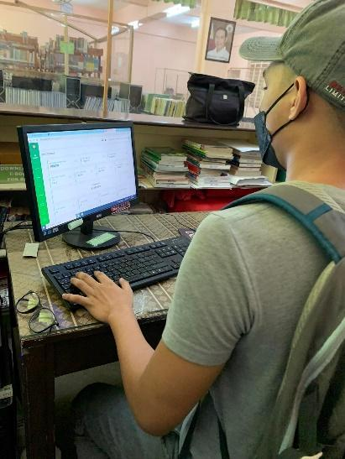





The Proponents went to School for their System Deployment for the Officers of FASA last May 02, 2022. They successfully deployed their system. The officers of FASA attended are Mr. Mel Oliver Balagtas (President), Ms. Irene Maclang (Auditor), and Ms. Diana Lyn Radores (Treasurer).

APPENDIX F

CURRICULUM VITAE

DHAN RYAN A. GUIÑES
Address: P4, Blk.12, L23, Sta. Clara Estates, Sta. Rita Guiguinto, Bulacan
E-mail: dhanryanguines@gmail.com
Mobile: (0956) 586 8846 ________________________________________________________________________
CAREER OBJECTIVE

“Looking for a challenging role in a reputable organization to utilize my technical, database, and management skills for the growth of the organization as well as to enhance my knowledge about new and emerging trends in the IT sector.”

PROFESSIONAL STRENGTHS AND QUALIFICATION

▪ Knowledgeable in IT-related Tasks
▪ Working knowledge in VB.net, HTML, CSS, PHP, JAVA Programing Language
▪ Photo Editing in Adobe Photoshop and Animating in Adobe Animate CC
▪ Proficient in MS Office Application
▪ Can communicate well (written and verbally)
▪ Team player, resourceful and creative in working any task
▪ Ability to do multi-tasking
▪ Willing to be trained and with an initiative to learn
▪ Reliable, honest, and conscientious worker
▪ Willing to work under pressure

EDUCATIONAL BACKGROUND

▪ Tertiary
Bulacan Polytechnic College Bachelor of Science in Information System Bulihan, Malolos Bulacan 2018 – Present

▪ Senior High
Science Technology Engineering Mathematics
Our Lady of Fatima University Valenzuela City
2016 – 2018

▪ Secondary
New Society National High School
General Santos City
2012 – 2016

▪ Primary
Seventh Day Adventist Elementary School
General Santos City
2006 - 2012

TRAININGS AND SEMINARS ATTENDED

▪ Participant
Regional Assembly on Information Technology Education (RAITE)
Webinar
November 2021

▪ Participant
International Research Conference in Information Technology Education (IRCITE)
Webinar
April 2022
PERSONAL INFORMATION
Date of Birth: January 14, 1999
Age: 23 years old
Sex: Male
Citizenship: Filipino
Civil Status: Single
Religion: Seventh Day Adventist

CHARACTER REFERENCE
▪ DIANA LYN RADORES
BPC FASA/FASA OFFICER
Bulacan Polytechnic College


I hereby certify that the above statements are true and correct to the best of my knowledge and belief.

DHAN RYAN A. GUIÑES
Applicant



DACEL JANE L. PAYTAN
Address: Unit 12 Purok 2 T. Garcia St. Tabang, Guiguinto, Bulacan
E-mail: dclpytn@gmail.com
Mobile: 0966-257-1427 ________________________________________________________________________
CAREER OBJECTIVE

“To enhance my abilities and gain more knowledge, to achieve advance skills regarding new technologies applied in our country, and to acquire new knowledge about the position to be applied for.”

PROFESSIONAL STRENGTHS AND QUALIFICATION

▪ Knowledgeable in IT-related Tasks
▪ Proficient in MS Office Application
▪ Can communicate well (written and verbally)
▪ Team player, resourceful and creative in working any task
▪ Ability to do multi-tasking
▪ Ready to learn new things.
▪ Reliable, honest, and conscientious worker
▪ Willing to work under pressure

EDUCATIONAL BACKGROUND

▪ Tertiary
Bulacan Polytechnic College Bachelor of Science in Information System Bulihan, Malolos Bulacan 2018 – Present

▪ Senior High
Technical Vocational (CCS)
Marcelo H. Del Pilar National High school
2016-2018

▪ Secondary
Marcelo H. Del Pilar National High school
Bagong Bayan, Malolos, Bulacan
2012 – 2016
▪ Primary
Tikay Elementary School
Tikay City of Malolos, Bulacan
2006 - 2012
TRAININGS AND SEMINARS ATTENDED
▪ Participant
Holder of National Certificate II in Computer Systems Servicing

▪ Participant
Regional Assembly on Information Technology Education (RAITE)
Webinar
November 2021

▪ Participant
International Research Conference in Information Technology Education (IRCITE)
Webinar
April 2022
PERSONAL INFORMATION
Date of Birth: December 05, 1999
Age: 22 years old
Sex: Female
Citizenship: Filipino
Civil Status: Single
Religion: Iglesia Ni Cristo

CHARACTER REFERENCE
▪ Jhon Michael R. Abainza
Assistant Manager
Malolos, Bulacan
0926-570-8934


I hereby certify that the above statements are true and correct to the best of my knowledge and belief.

DACEL JANE L. PAYTAN
Applicant



JUDY ANN G. PALMA
Address: Blk 8, Lot 10 the Grove Calumpit Bulacan
E-mail: judyannpalma1999@gmail.com
Mobile: (0967) 5435552 ________________________________________________________________________
CAREER OBJECTIVE

“A highly disciplined and hard-working individual looking for a responsible position to gain good experience.”

PROFESSIONAL STRENGTHS AND QUALIFICATION

- Can manage time.
- Can easily adapt to new environments.Can work without supervision.
- Ready to learn new things.
- Good interpersonal and communication skills.
- Demonstrated ability to read and follow instructions.
- Knowledgeable in IT-related Tasks
- Proficient in MS Office Application
- Reliable, honest, and conscientious worker
- Willing to work under pressure

EDUCATIONAL BACKGROUND

▪ Tertiary
Bulacan Polytechnic College Bachelor of Science in Information System Bulihan, Malolos Bulacan 2018 – Present

- Senior High Emmanuel John Institute of Science & Technology
2017-2018

▪ Secondary
San Matias National High school
Sto.Tomas San Matias
2012 – 2016

▪ Primary
San Agustin Elementary School
San Agustin San Simon Pampanga
2006 – 2012

TRAININGS AND SEMINARS ATTENDED

▪ Participant
Regional Assembly on Information Technology Education (RAITE)
Webinar
November 2021

▪ Participant
International Research Conference in Information Technology Education (IRCITE)
Webinar
April 2022
PERSONAL INFORMATION
Date of Birth: August 08, 1999
Age: 22 years old
Sex: Female
Citizenship: Filipino
Civil Status: Single
Religion: Catholic

CHARACTER REFERENCE
▪ JEROME TUANO
IT EXPERT
San Simon Pampanga
09675869789

I hereby certify that the above statements are true and correct to the best of my knowledge and belief.

JUDY ANN G. PALMA

